

# Preamble

Reproducibility is one of the most fundamental cornerstones of science. Research results are typically considered replicable if there is sufficient information available for independent researchers to obtain the same findings using the same methods with new data. Working to make your research reproducible surely requires extra upfront effort but beyond the direct benefit to science, succeeding can also benefit you personally by making your research process more effective and easier (Gandrud 2015; Xie 2015).

Cutting-edge statistical analysis often requires tools not yet available in commercial software-packages and the open-source programming language and development environment R has gained increased acceptance within the research community as it provides one solution to these problems. In this workshop you will learn how to use RStudio and R Markdown as one tool integrating data storage, analysis, graphing, and manuscript writing. You will first learn how to create your own R-package to store data, code, and share your research with other people. You will then learn how to use R Markdown to integrate data analysis, graphing, and manuscript writing.

To be able to complete this workshop, participants are required to install all the R-packages listed below. Windows users must also install the latest version of the RTool application.

* htmltools (RStudio and Inc. 2016),
* caTools(Tuszynski 2014),
* bitops (Steve Dutky initial R port, Martin Maechler; revised, and Steve Dutky 2013),
* base64enc (Urbanek 2015),
* rmarkdown (Allaire et al. 2016),
* devtools (Wickham and Chang 2017),
* roxygen2 (Wickham, Danenberg, and Eugster 2017),
* knitr (Xie 2015), and
* ggplot2 (Wickham 2009).
* plyr (Wickham 2011)

You can do so using the following script.

#"This script installs R packages required to complete the Workshop Tutorial"  
  
# lists all packages already installed  
packages.list <- rownames(as.data.frame(installed.packages()))  
  
# lists all packages that must be installed  
packages.required <- c("htmltools", "caTools", "bitops", "base64enc", "rmarkdown",   
 "devtools", "roxygen2", "knitr", "ggplot2", "plyr")  
  
# install missing packages  
for(package in packages.required){ # iteration over required packages  
 if(package %in% packages.list == F){ # if package has not been installed yet  
 install.packages(package)  
 }  
}

# Section 1. Creating an R-Package

Are you looking for an efficient way to store your data, metadata, and code to share your research with others or simply to make it easier on yourself? Stop looking, the solution is simple: you need to create your own R-package! The simplest way to create an R-package is to use the devtools and roxygen2 packages and this first section will get you started with creating you own R-packages using these two libraries. You will be guided through a step by step tutorial. The following topics will be covered: including and documenting datasets as well as functions within an R-package, file structure, and exporting the package in a format that you can share with other users

## 1. Create a New Project.

1. Click on Project: (None), and select New Project.

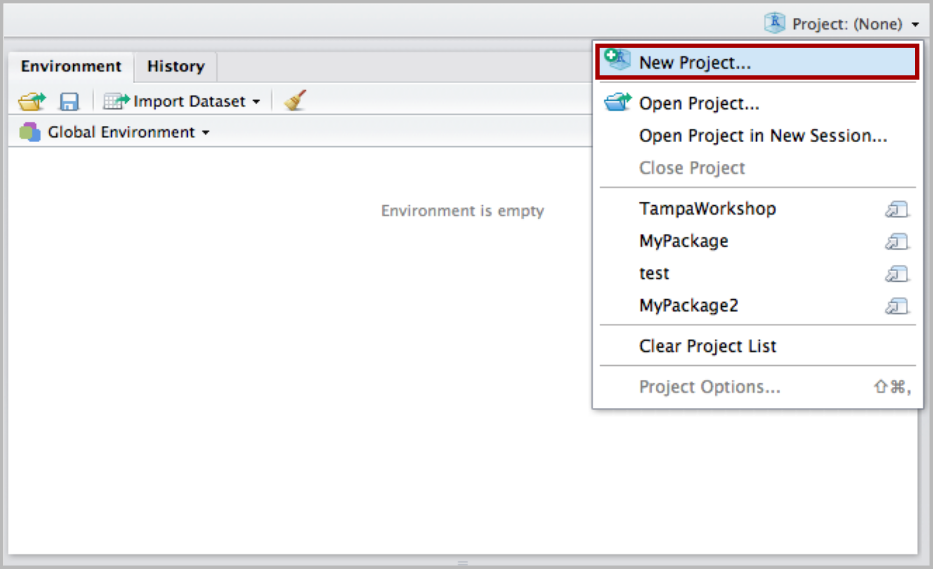

1. Select New Directory.

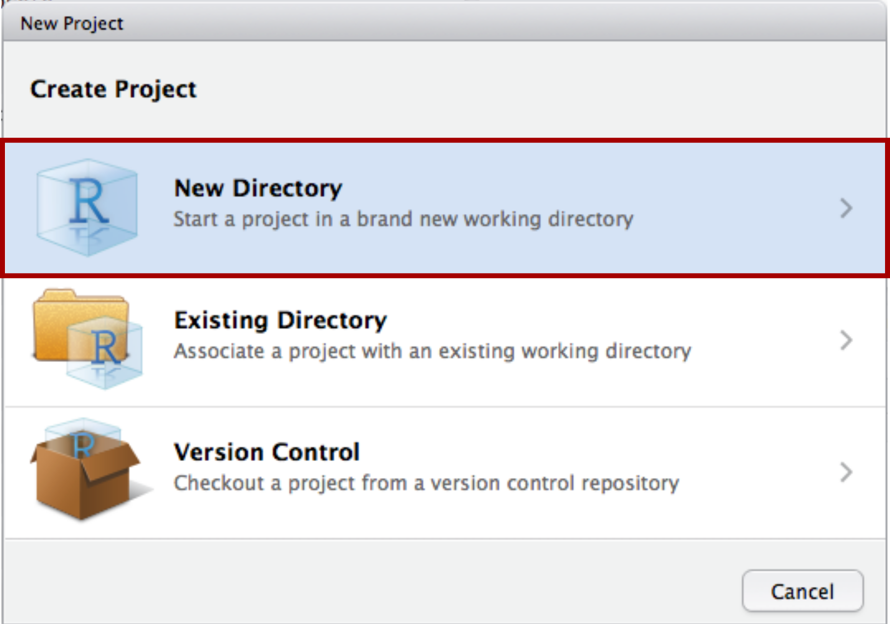

1. Select R Package.

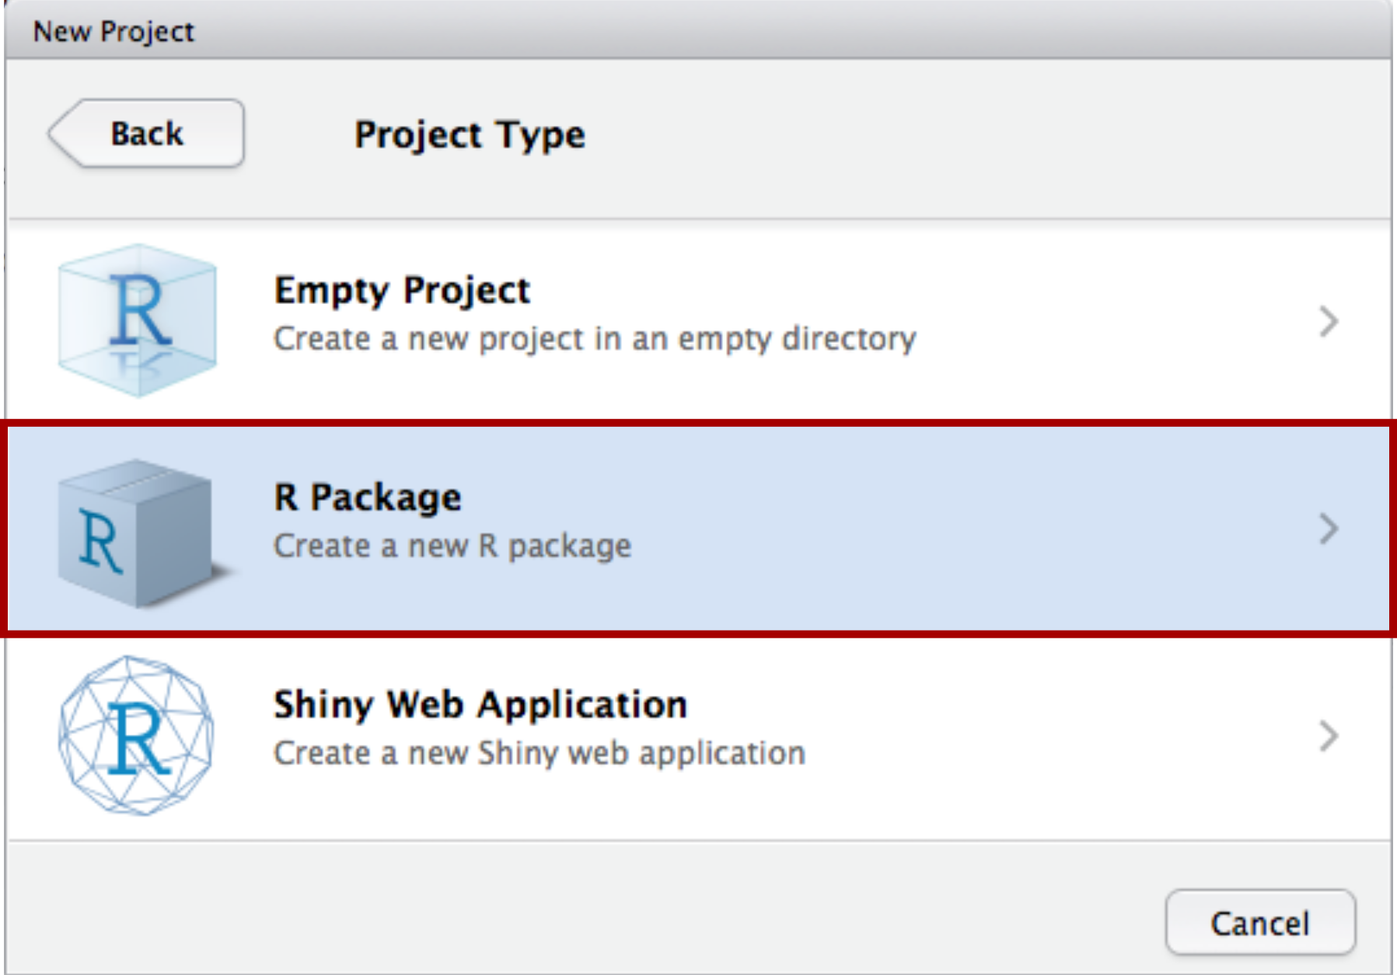

1. Name your package, select the directory in which your project/package will be located, and click on Create Project.

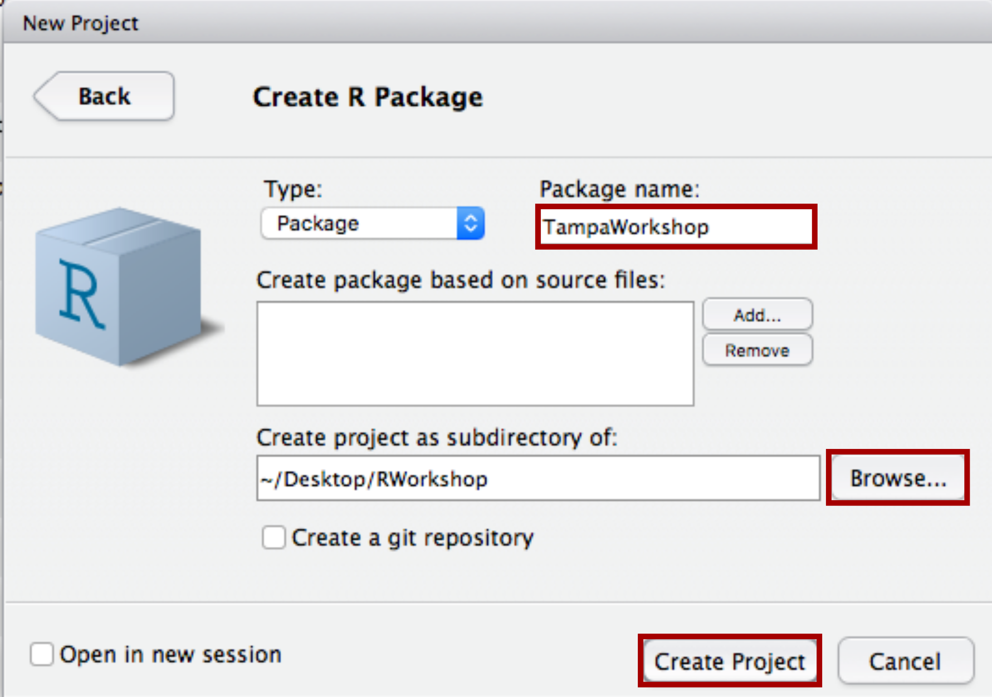

1. You should obtain the following screen.

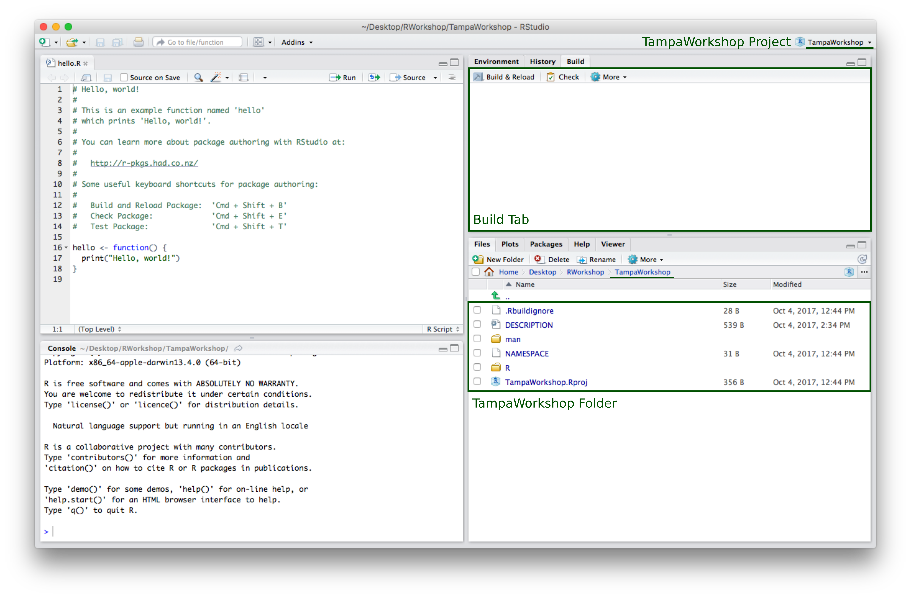

1. In the main drop-down menu click on Build and select Configure Build Tools.

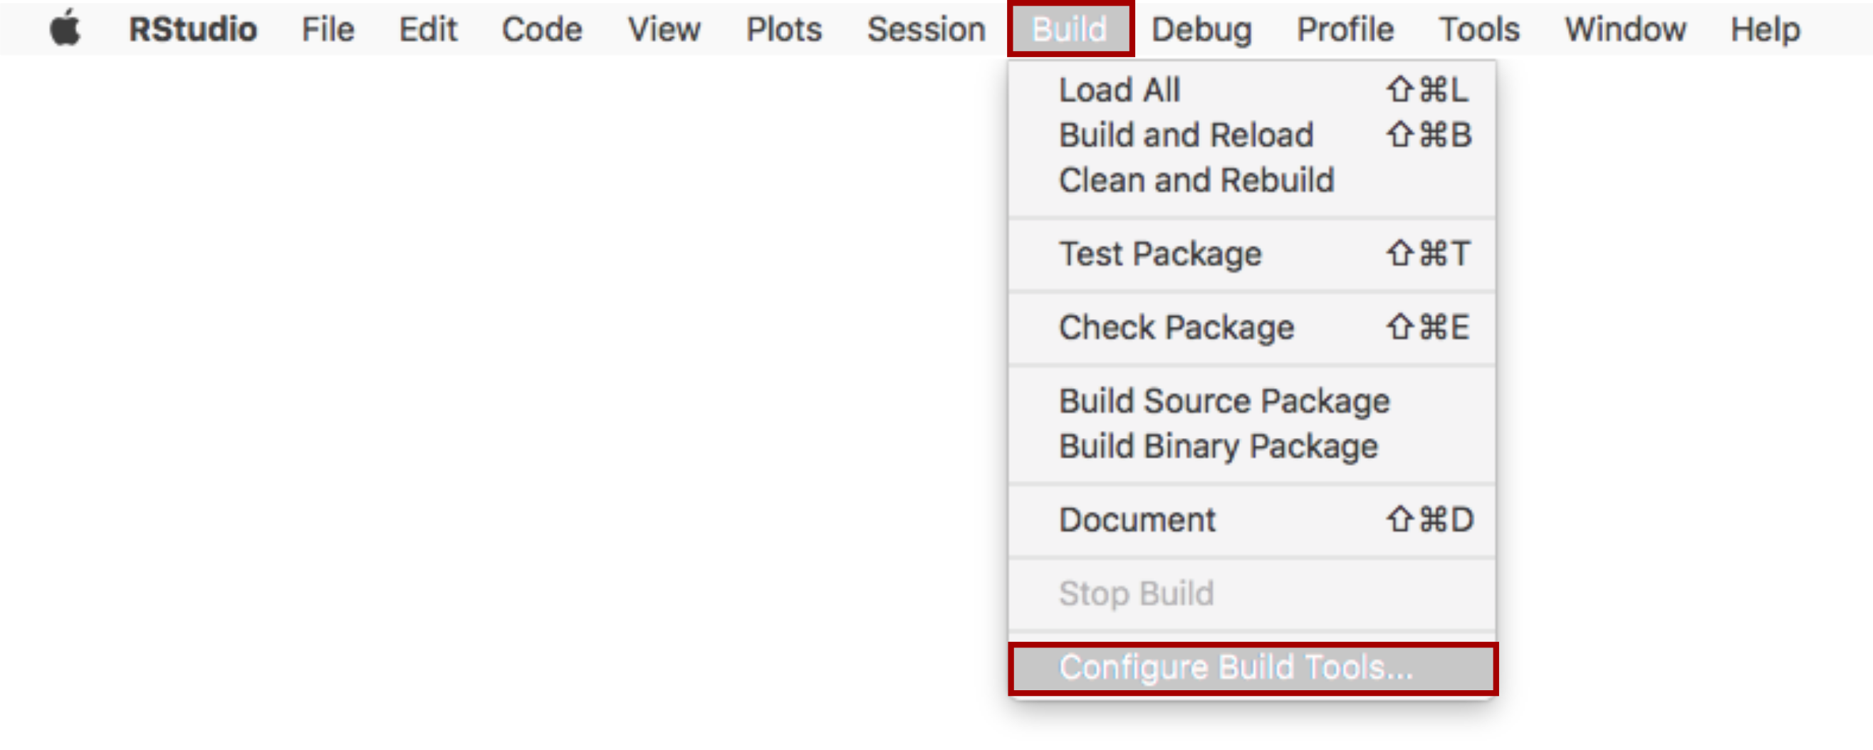

1. In the Build Tools Tab, check the option Generate documentation with Roxygen. If this was already checked, click on Configure.

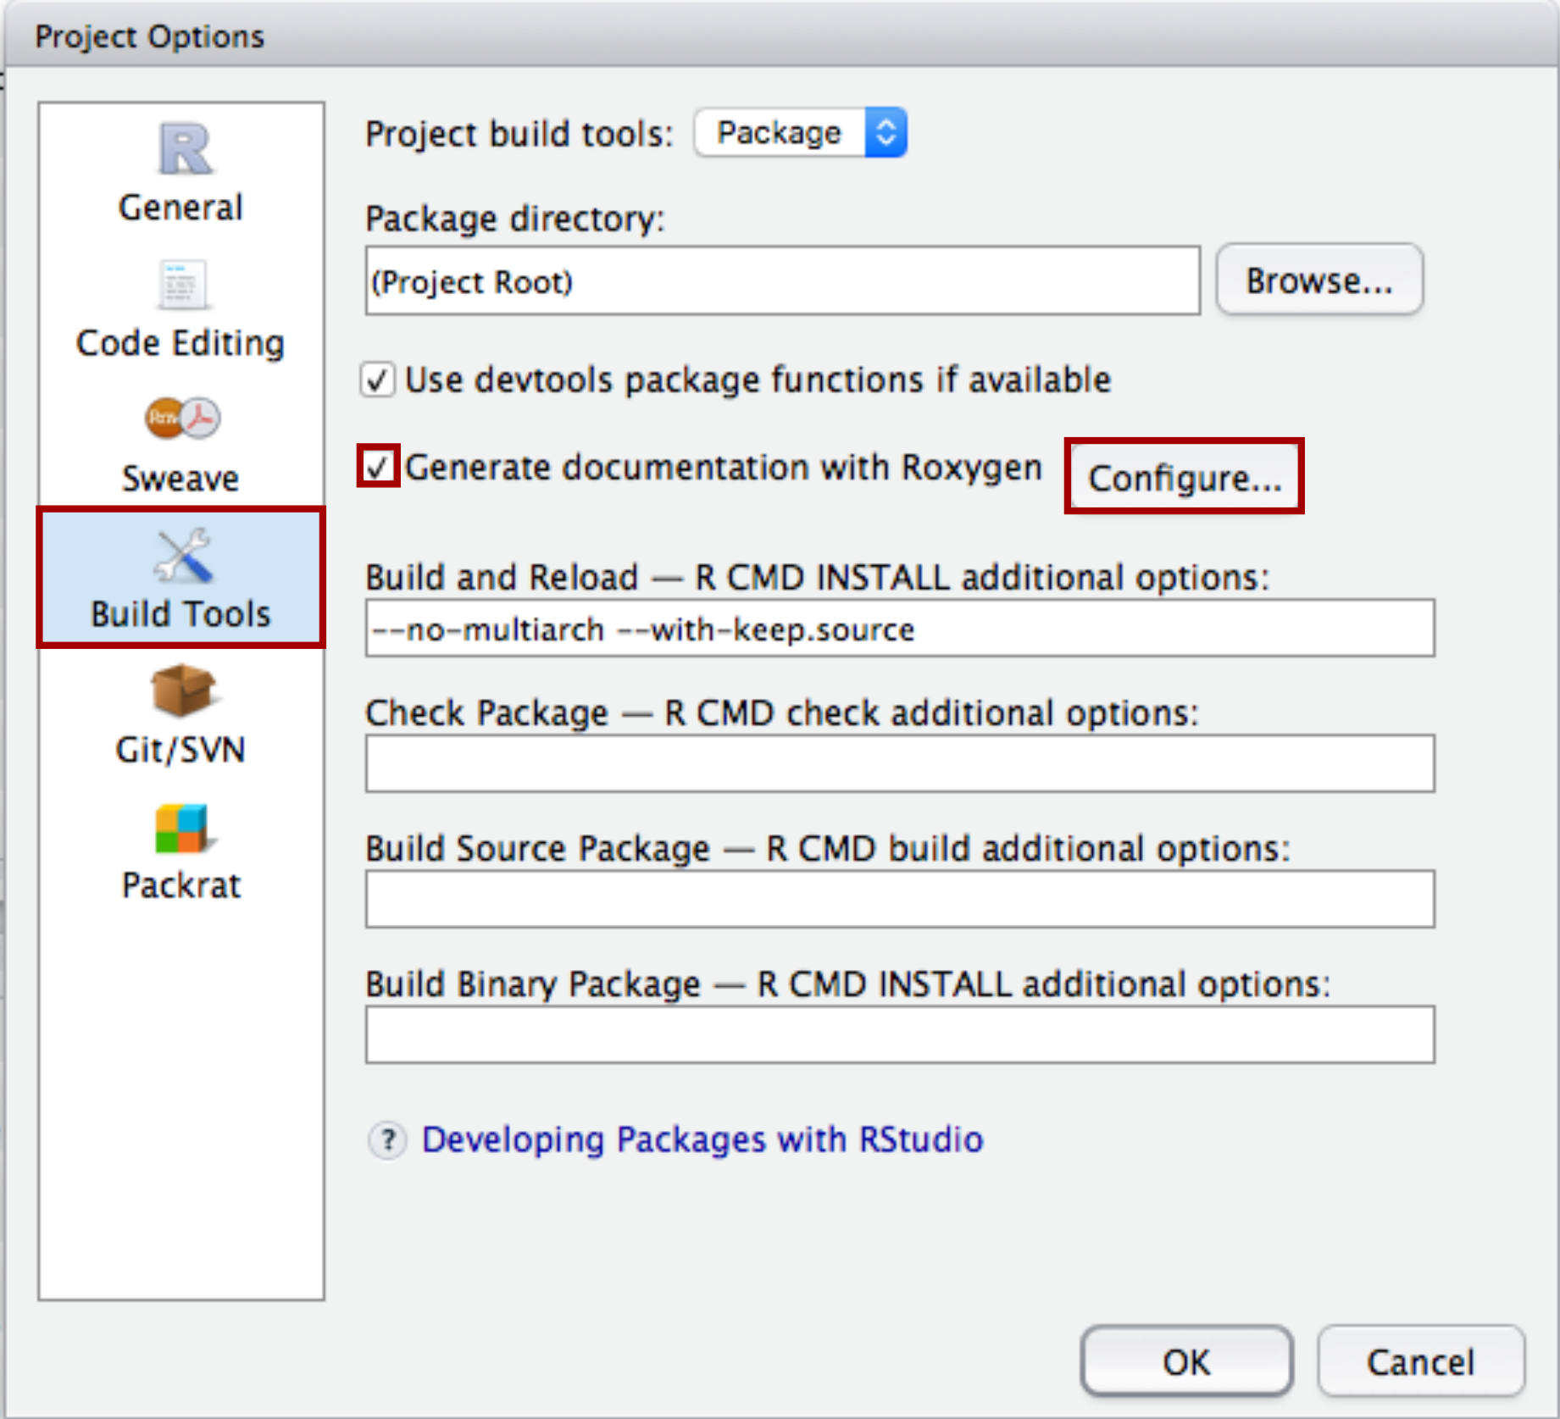

1. In the Roxygen Options window, check all options and click OK. Click OK again to exit the Project Options window.

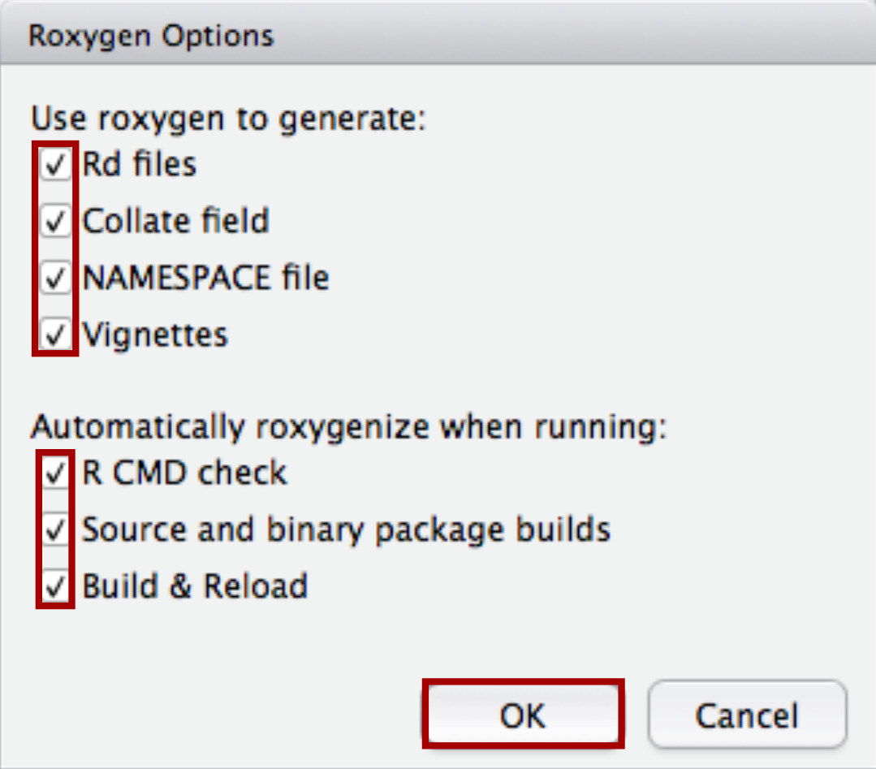

## 2. Complete the DESCRIPTION File.

1. Open the DESCRIPTION file from the file window in RStudio.

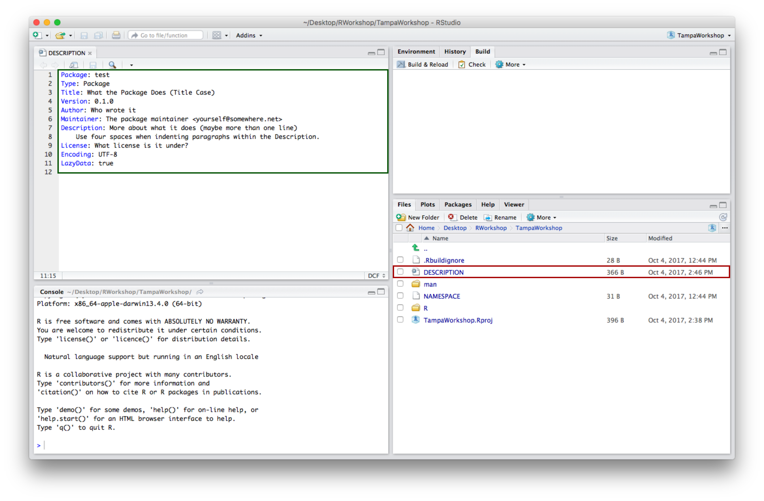

1. Edit the file and click on Build & Reload or Install & Restart depending on which R and RStudio versions are installed on your computer.

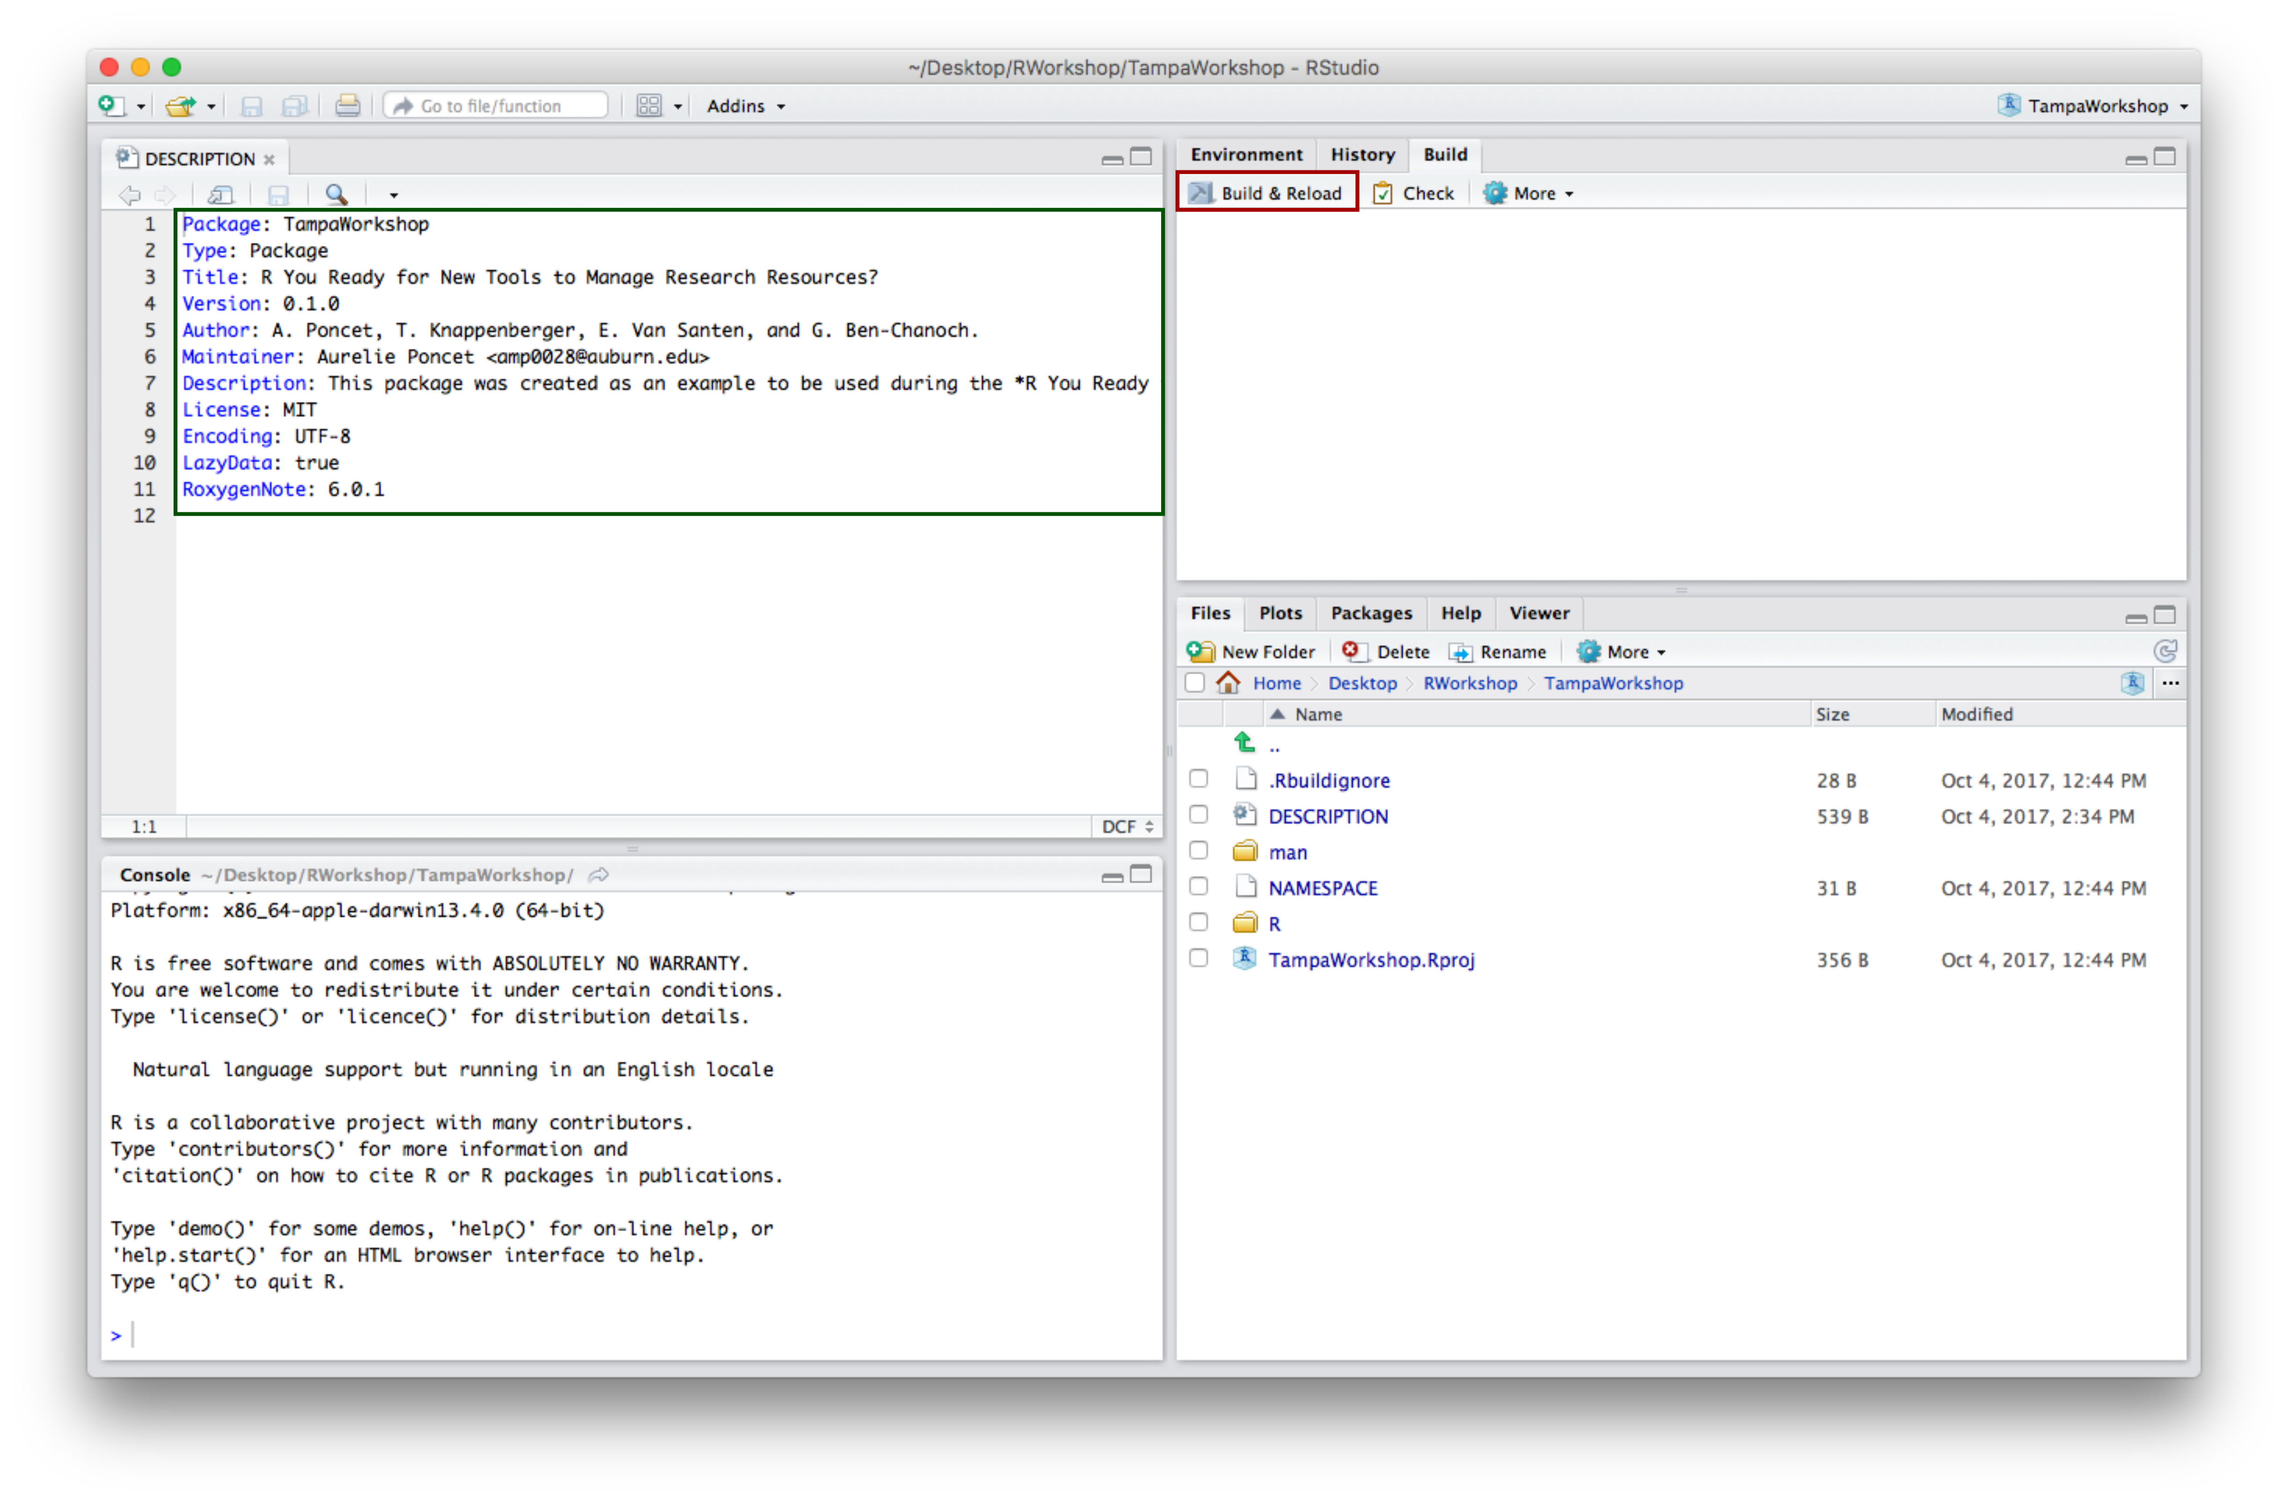

1. After clicking on Build & Reload (or Install & Restart), your package has been loaded to the Packages tab.

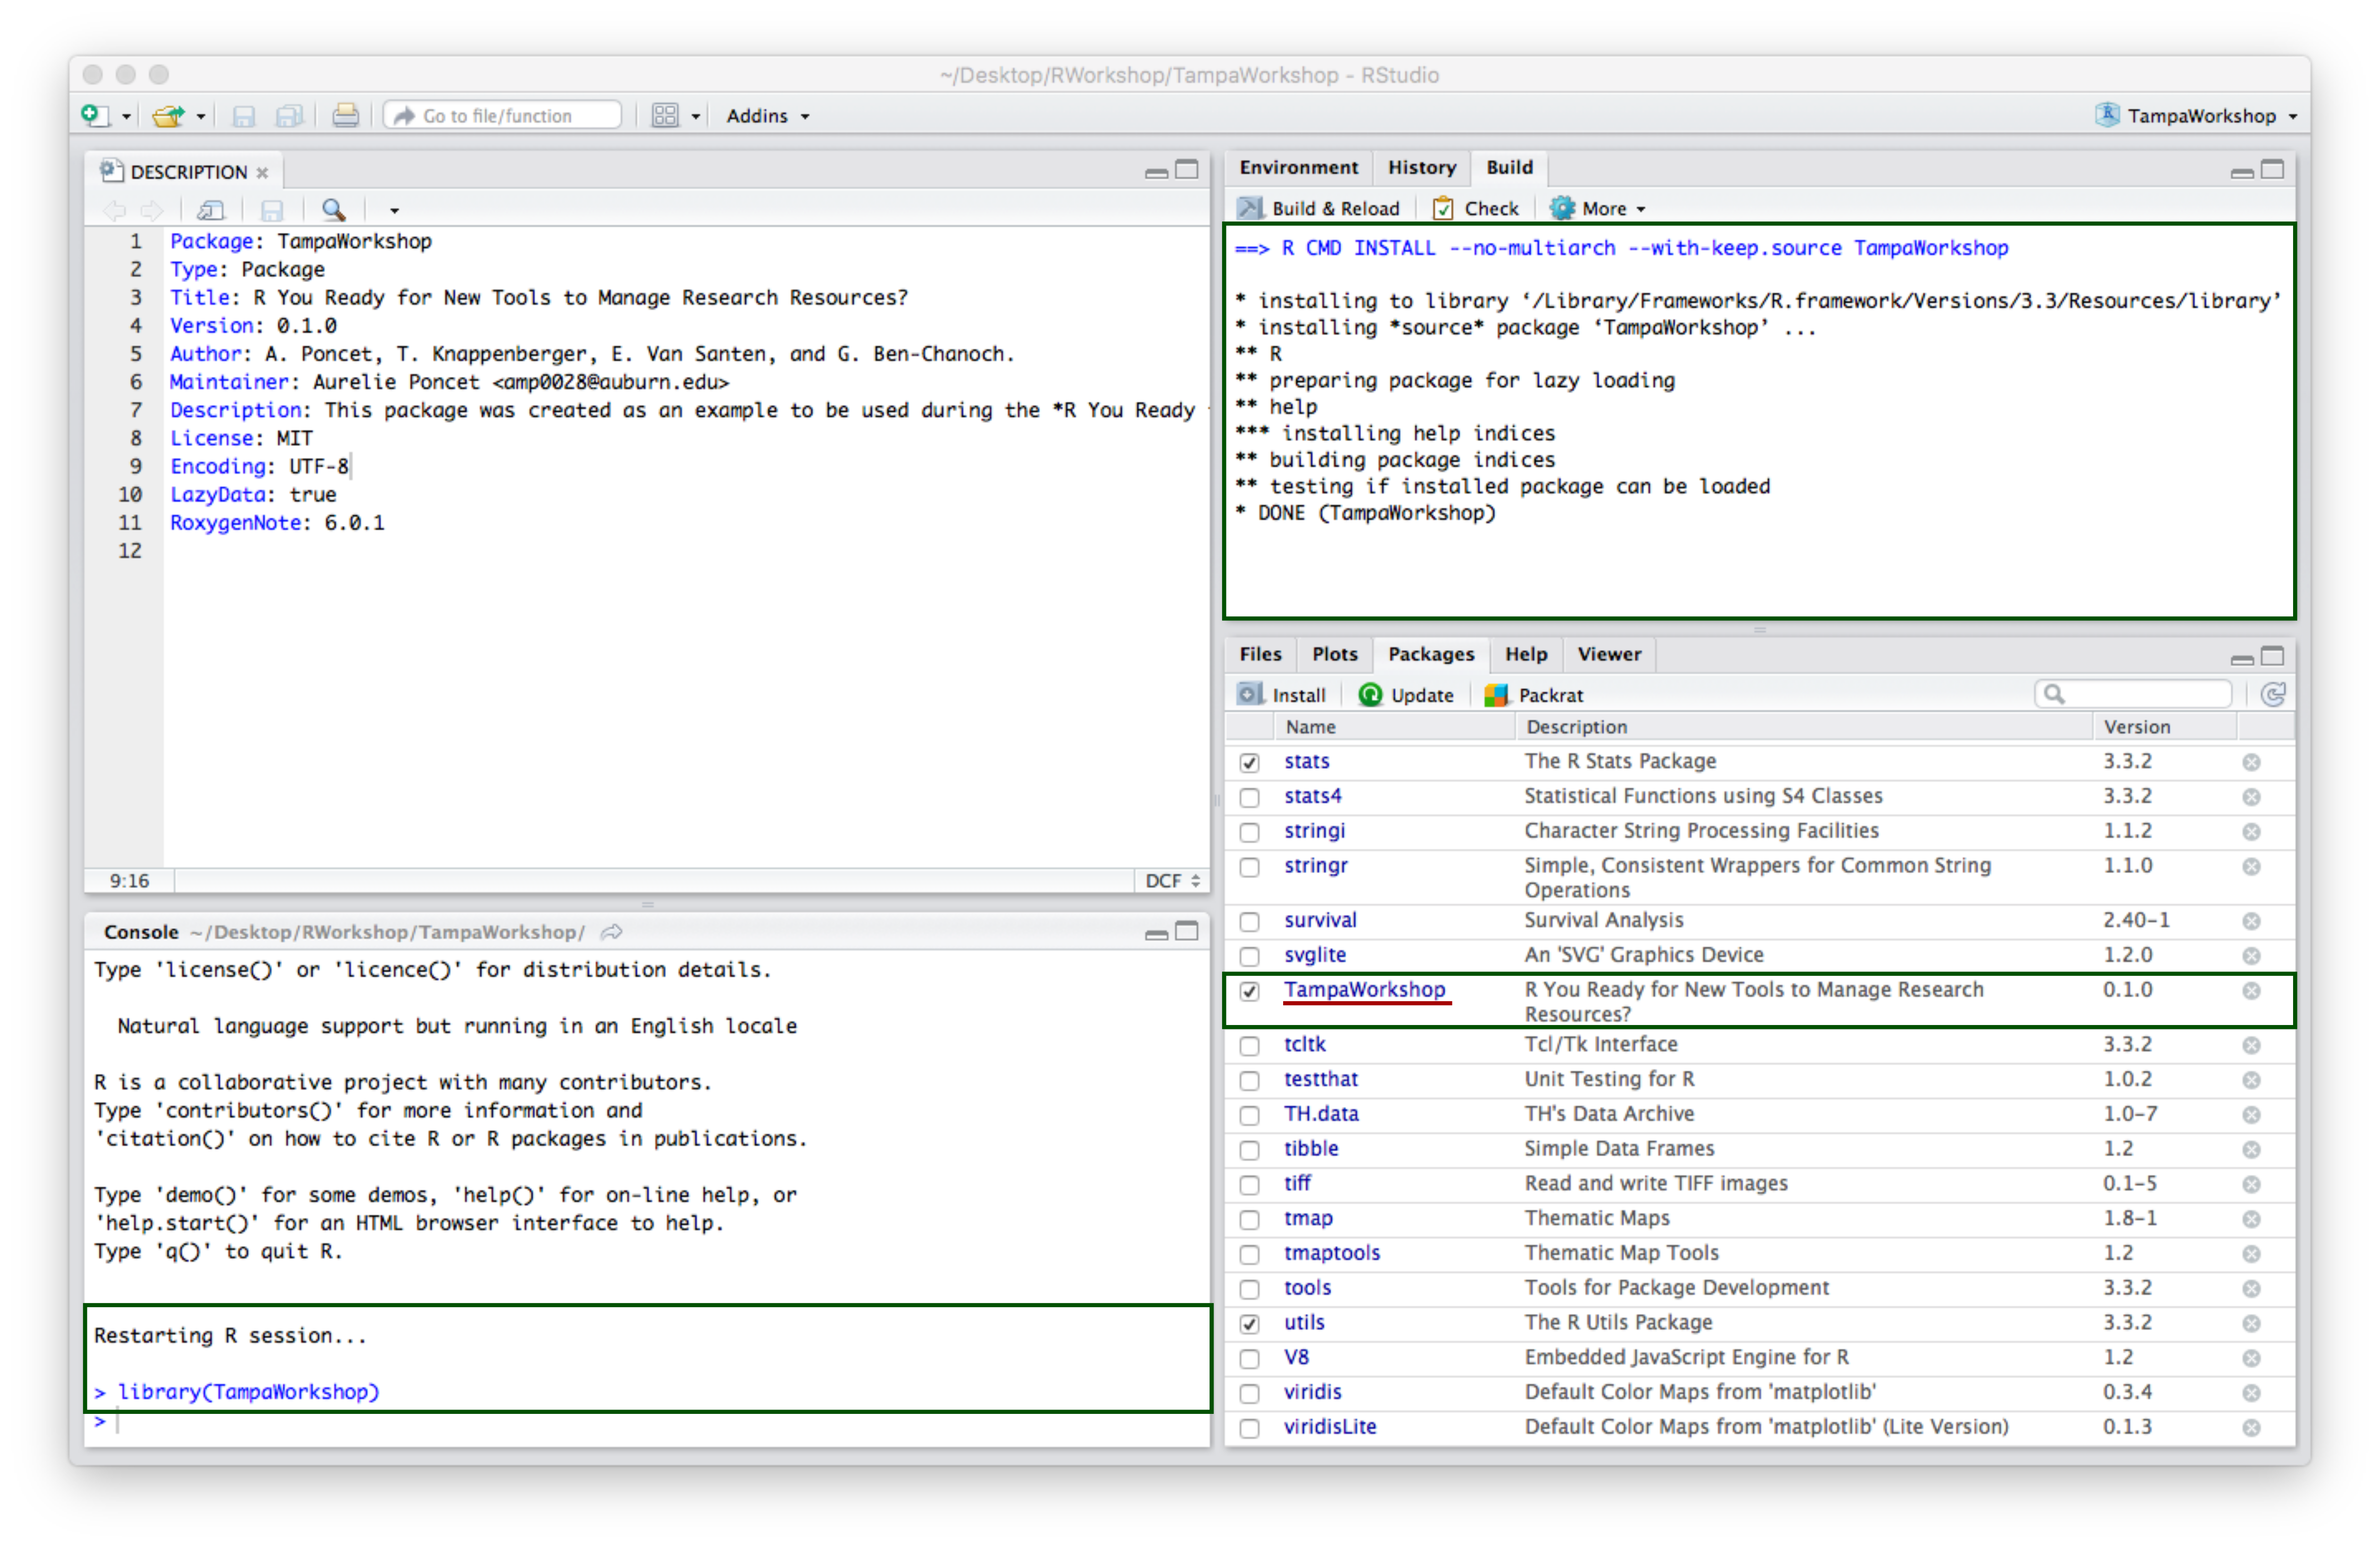

1. Click on your package within the help screen to access its information.

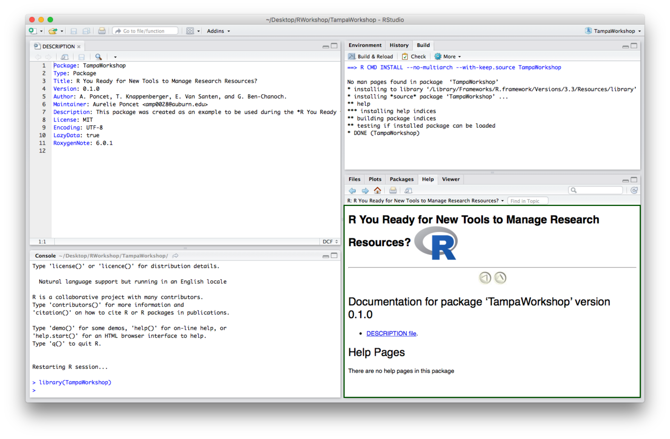

## 3. Add and Document a Dataset.

1. Save the original data files (here .csv files) within a Source folder located outside of the TampaWorkshop package folder.

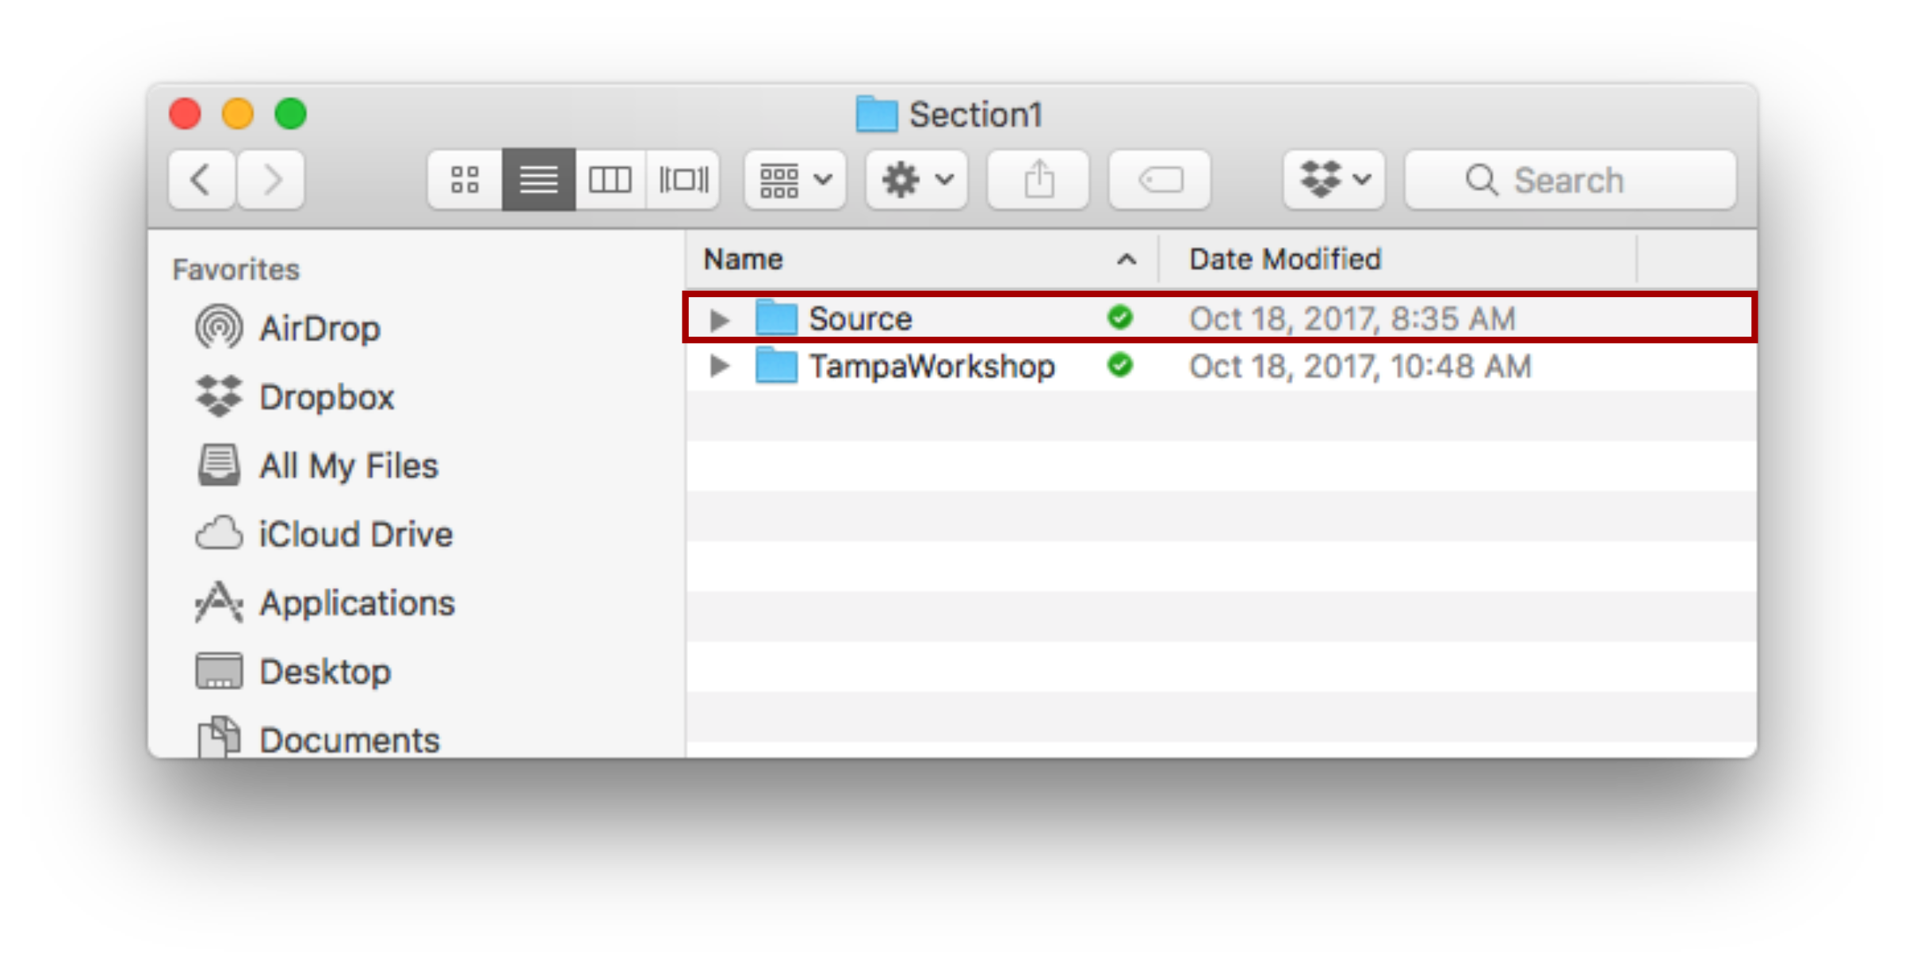

1. Data within a R-package must be stored within a data folder. Hence, within the TampaWorkshop folder create a new folder named data.

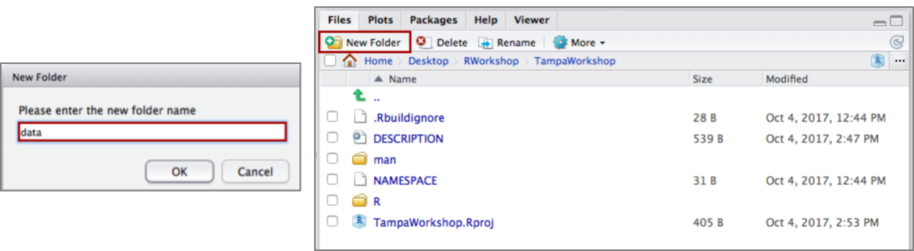

1. Import your data into RStudio. Save data as .rda into the data folder created step 3b. Save the script created to import the data within the Source package created step 3a.

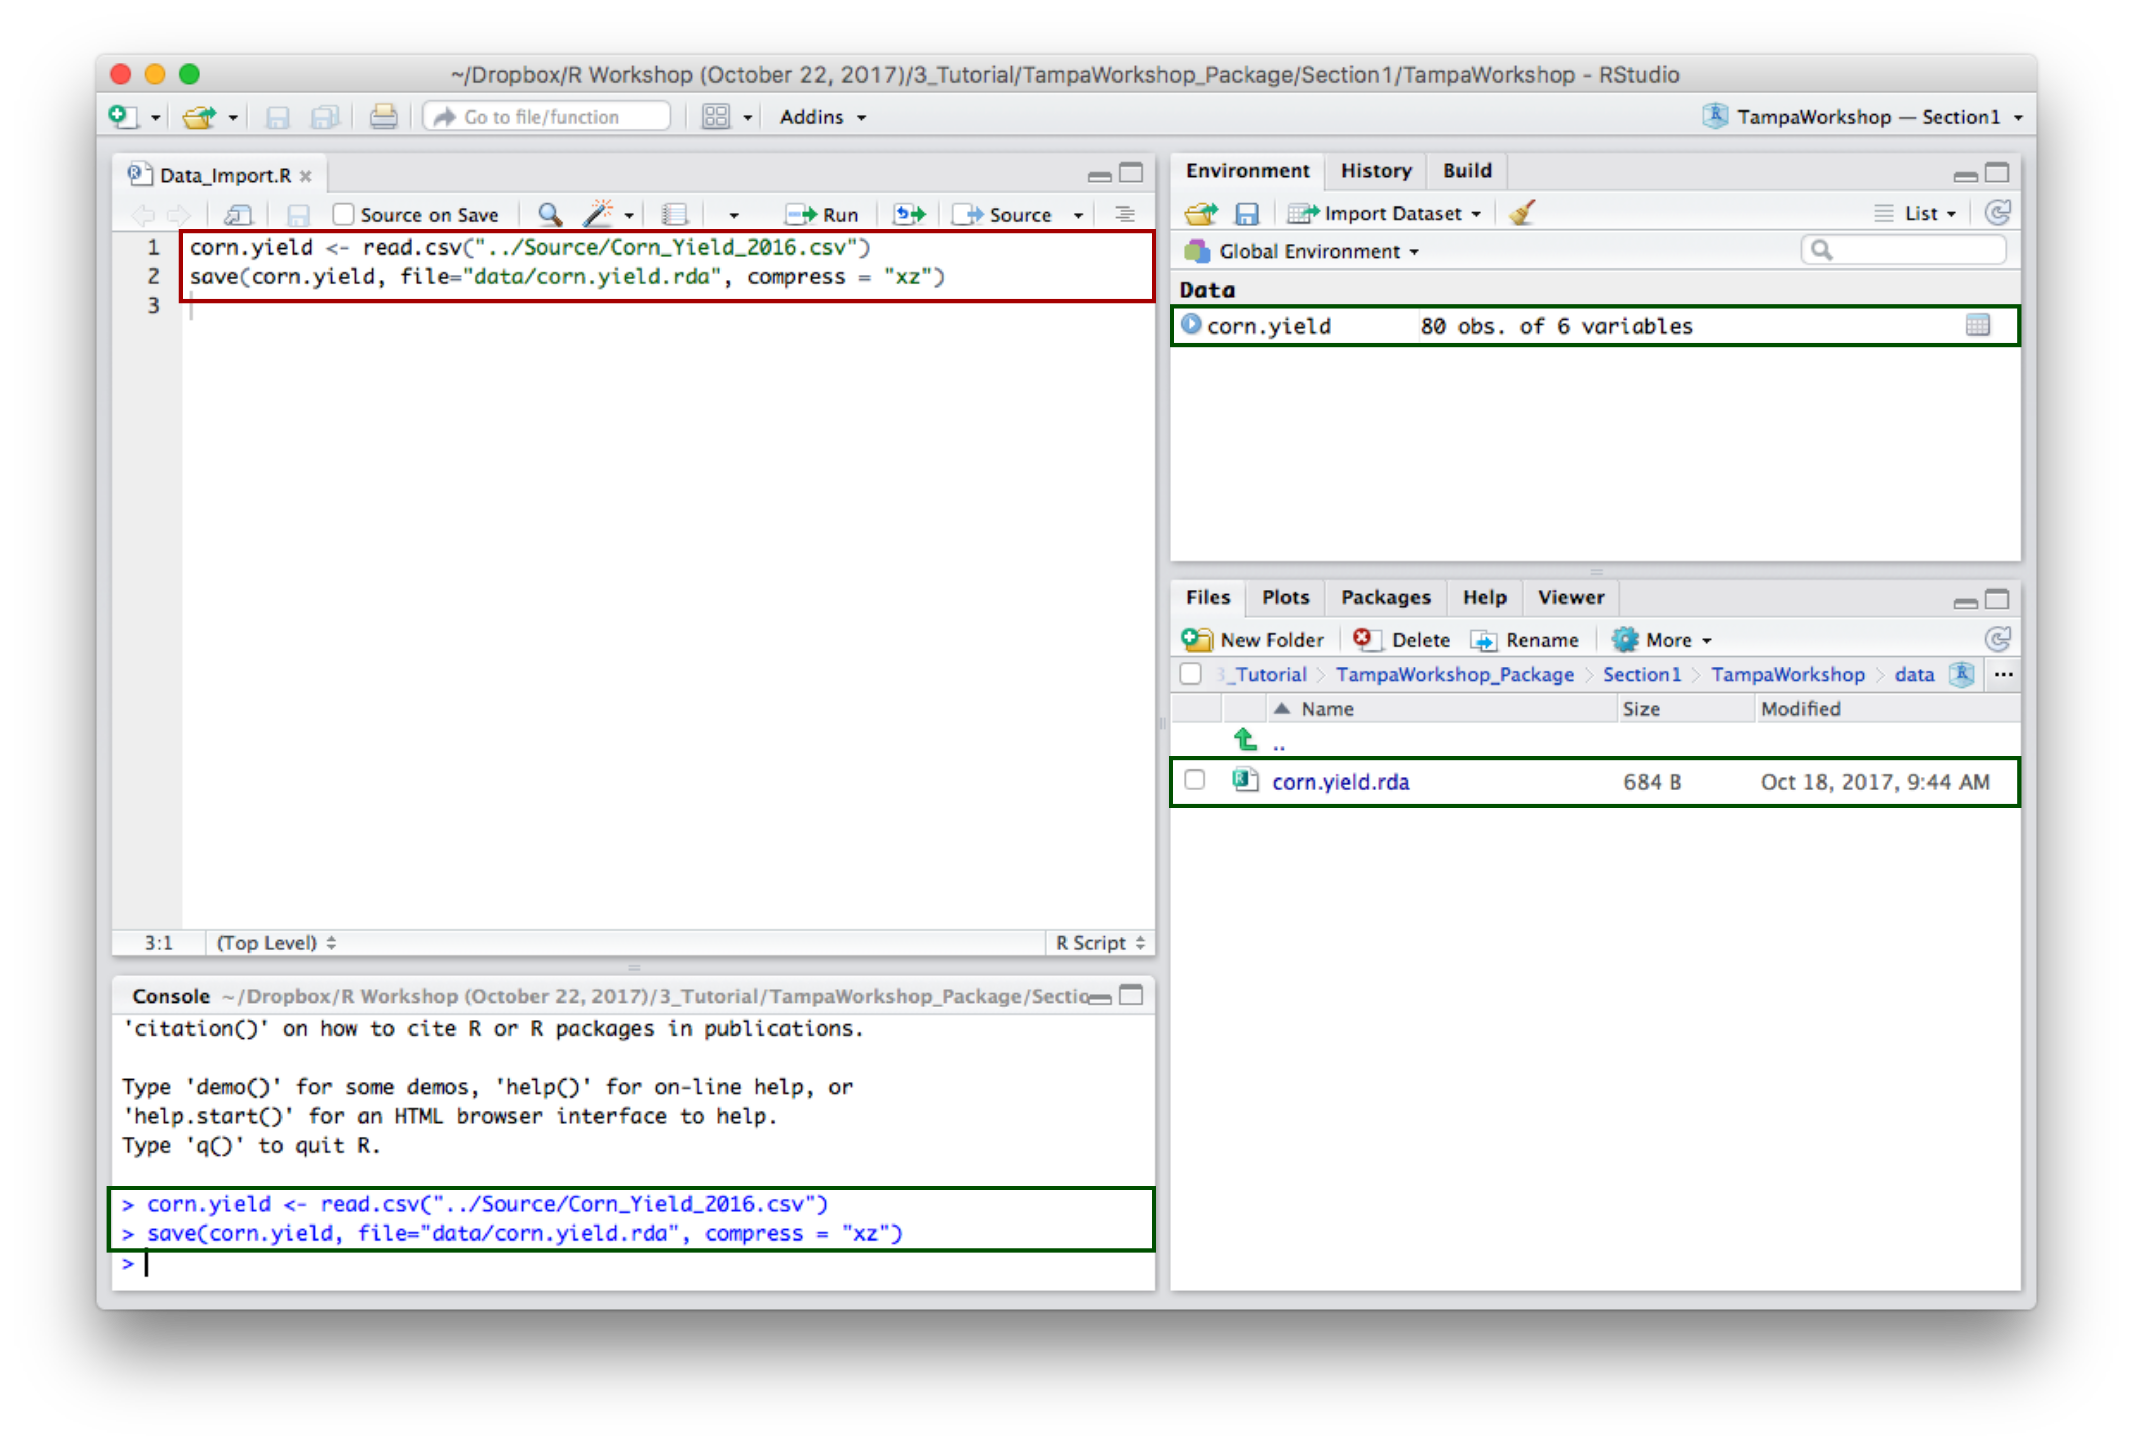

1. Document the dataset. Start a new script and save within the package R folder. Metadata with roxygen2 are added following #' (pound plus single quote). The first line must state the title of the dataset. The line below remains blank. The third line provides a short description of the dataset. Dataset individual columns are defined using \\itemize and \\item. The name of the dataset and how the dataset is imported in R are defined using respectively \@name and \@usage. \@export is required to ensure that the dataset will be available after exportation.

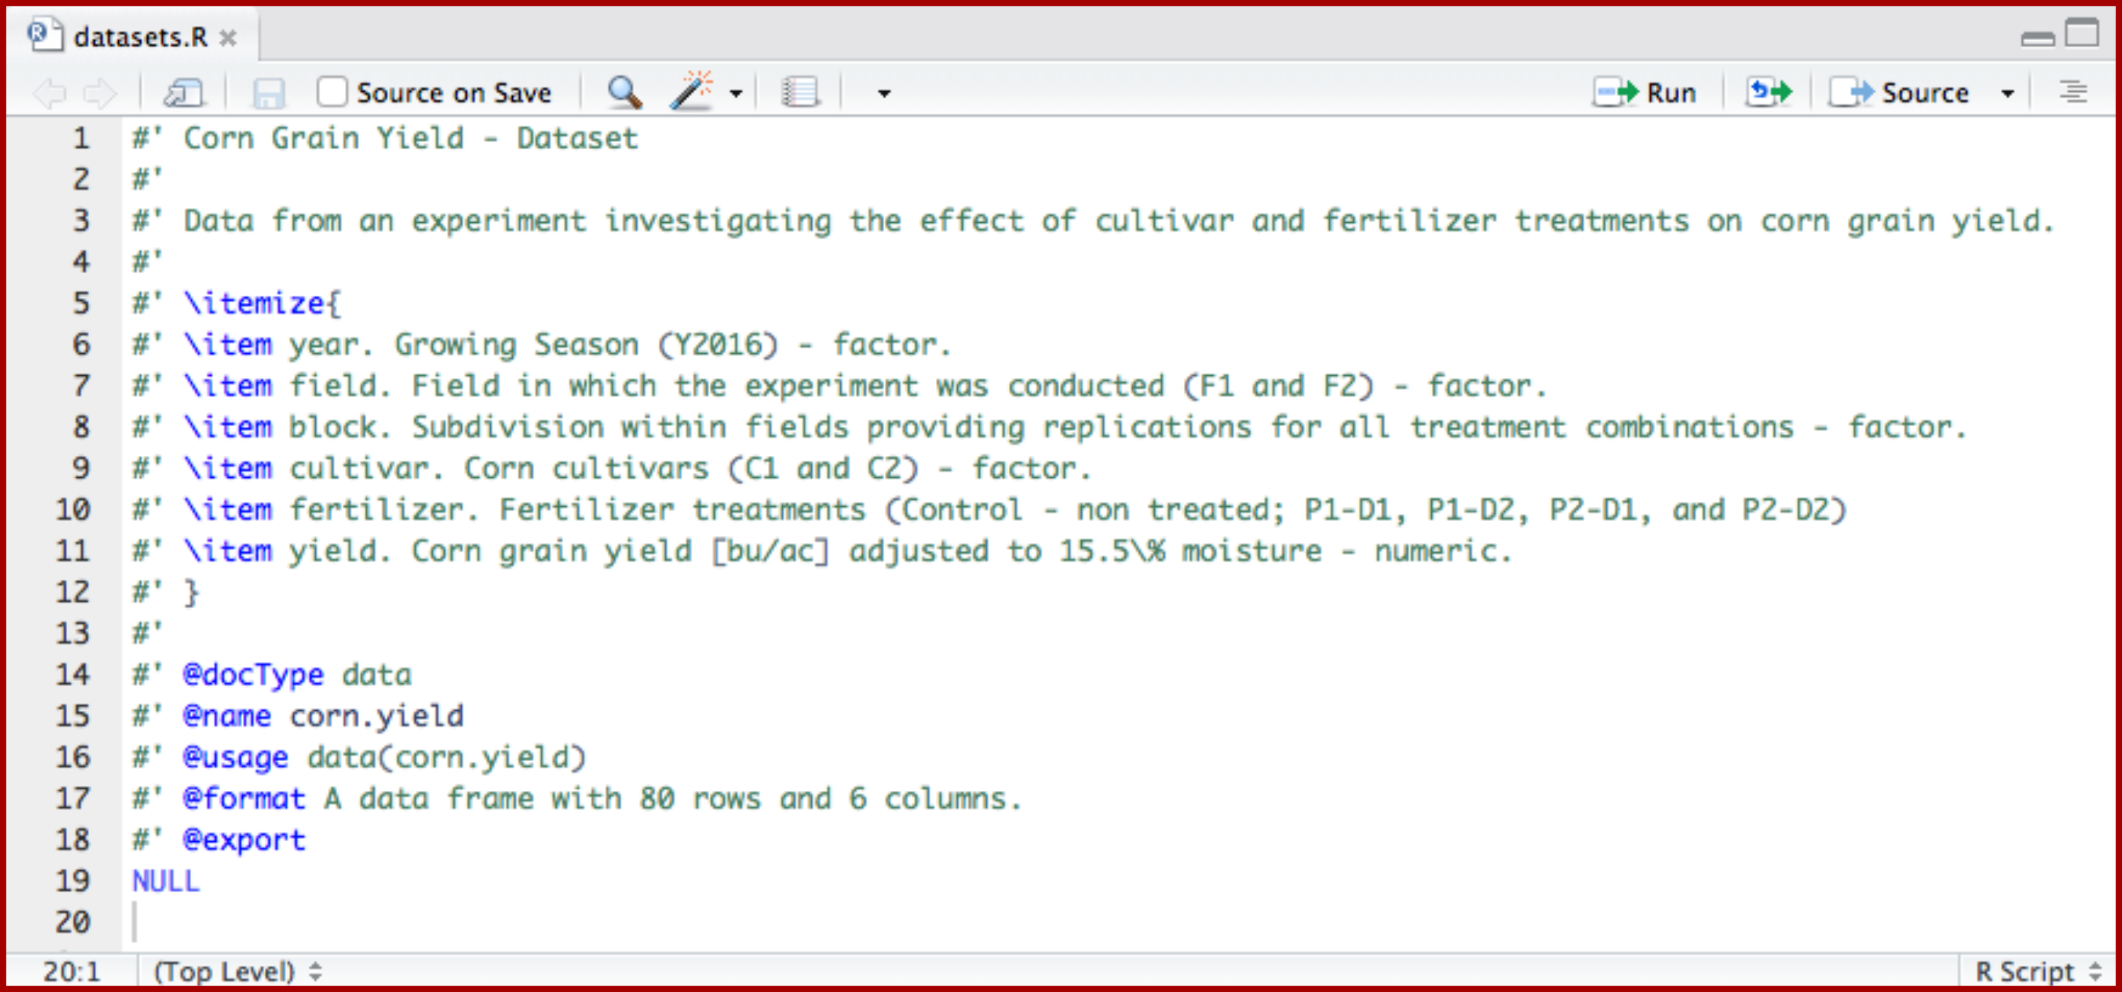

1. Click on Build \& Reload - or Install & Restart - to update your package in the Packages tab. Use ?dataset.name (here ?corn.yield) to see the dataset medata in the help screen.

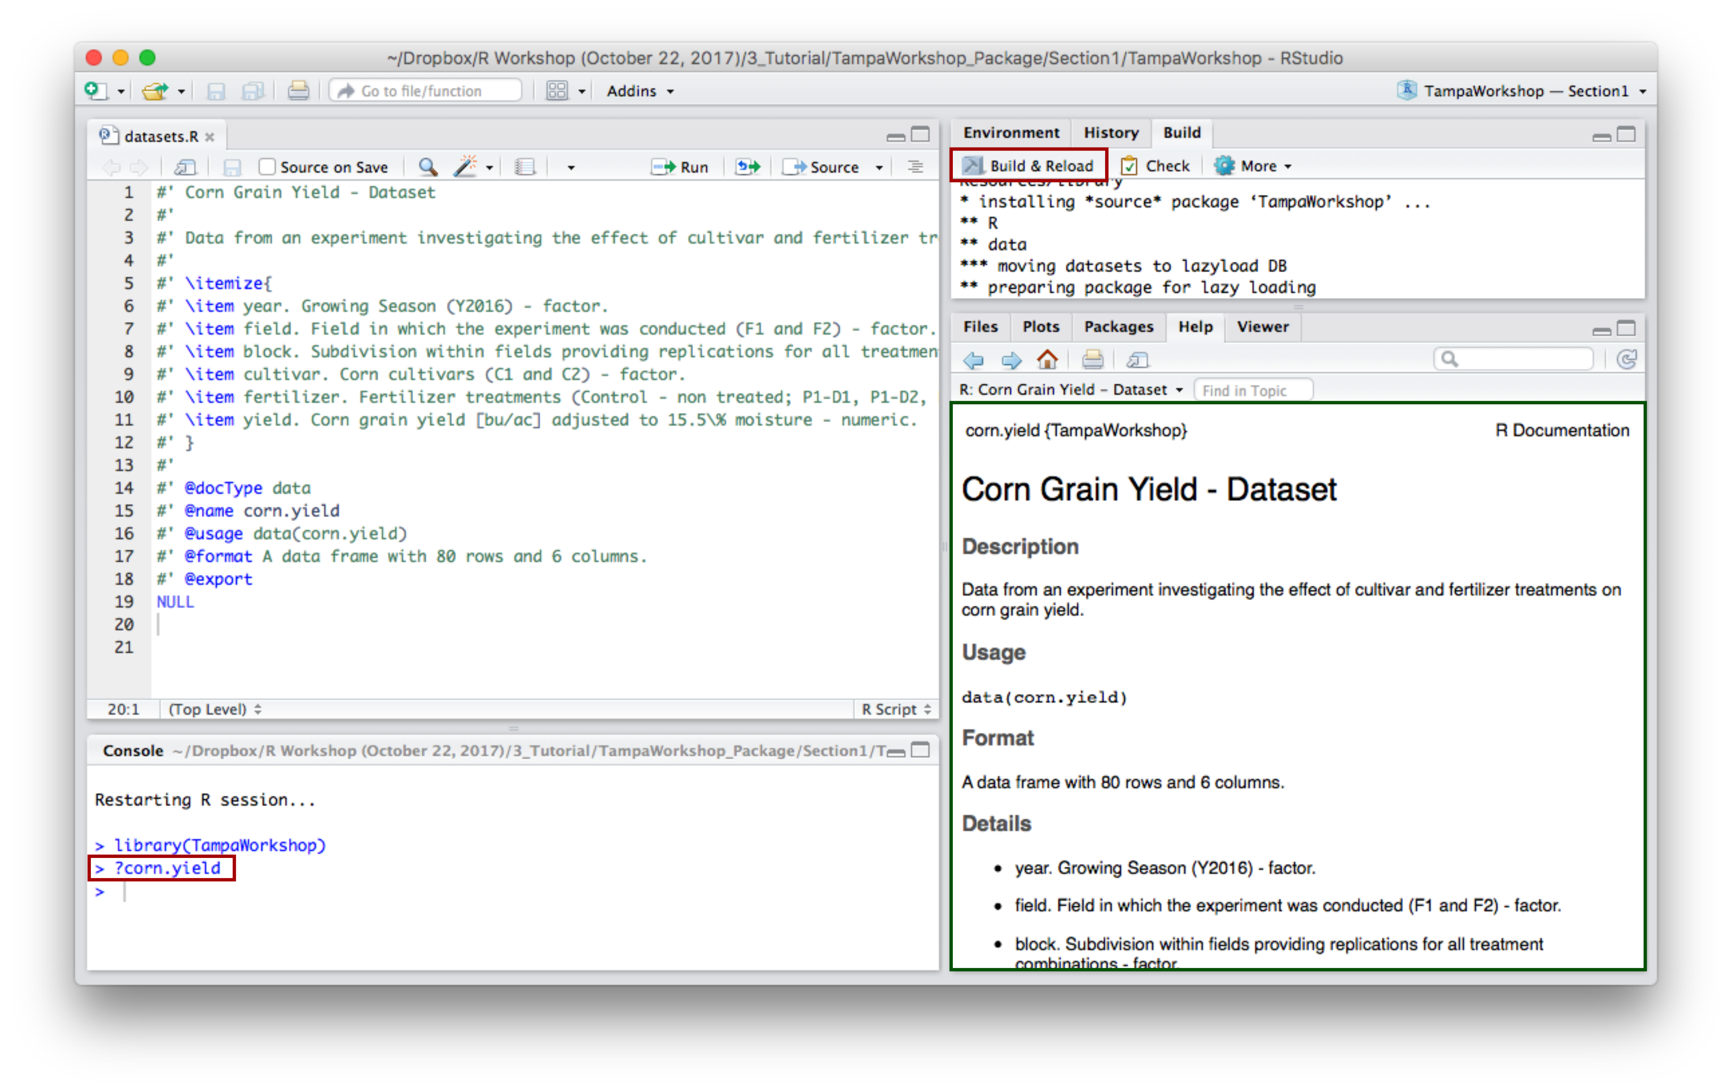

## 4. Add and Document a Function.

1. Create a new script and save into the TampaWorkshop package R folder. Write your function.

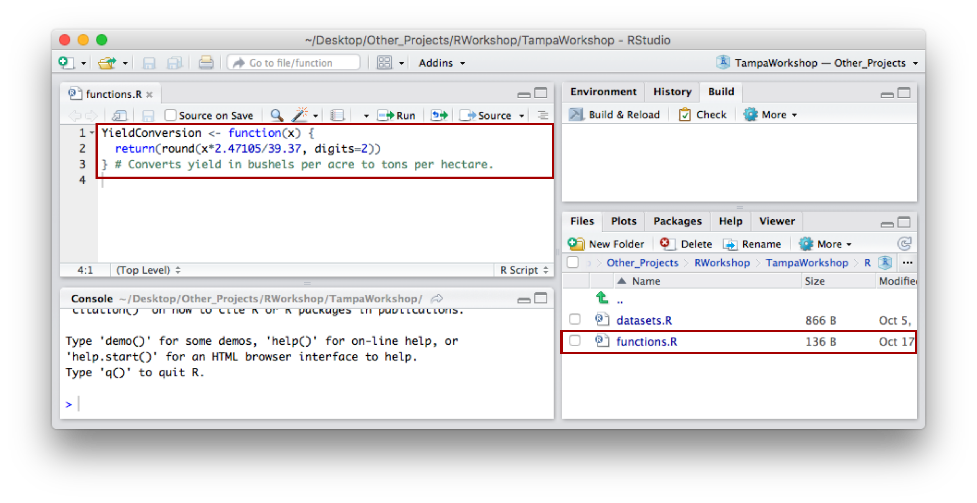

1. Add meta data to the function. As we have seen before, metadata are specified following #'. The first line must state the title of the function. The line below remains blank. The third line provides a short description of the function.The function parameters and output are defined using \@param and \@return. Examples are provided below \@example.\@export is required to ensure that the dataset will be available after exportation.

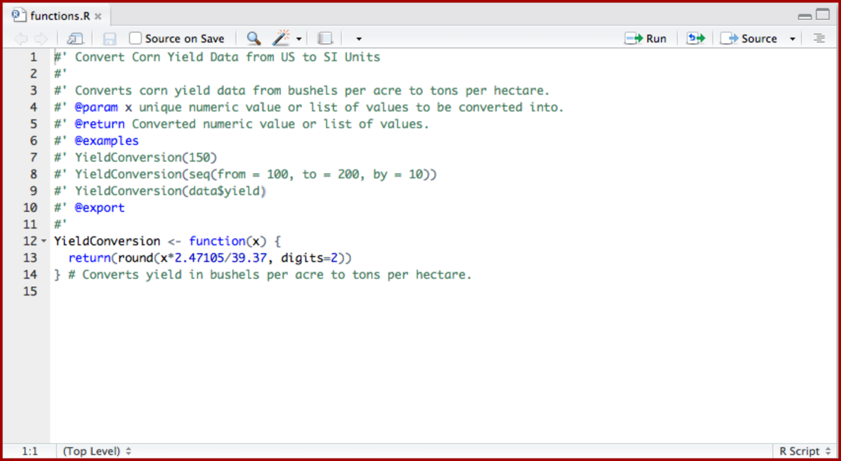

1. Click on Build \& Reload - or Install & Restart - to update your package in the Packages tab. Use ?FunctionName (here YieldConversion) to see the function medata in the help screen.

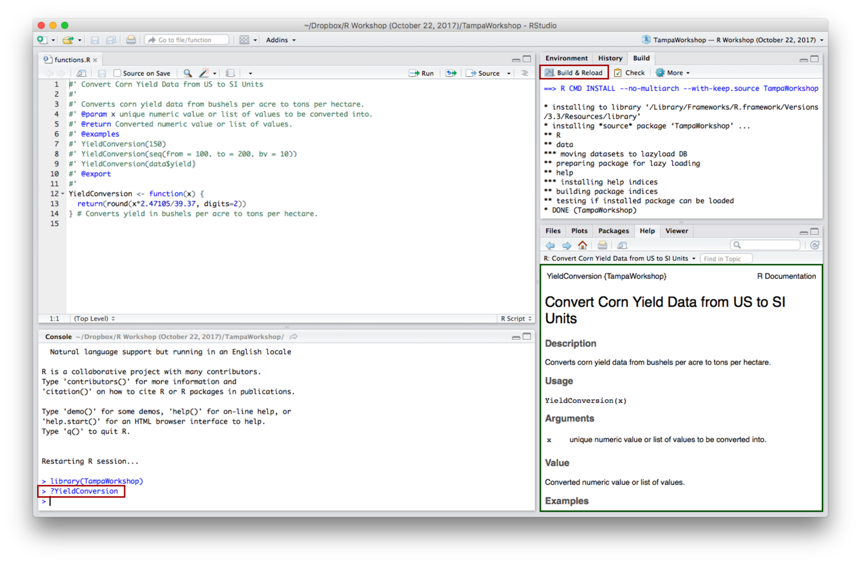

## 5. Document and Build the Package.

1. In console, import devtools and execute use_package_doc(). This creates a new file in the package R directory.

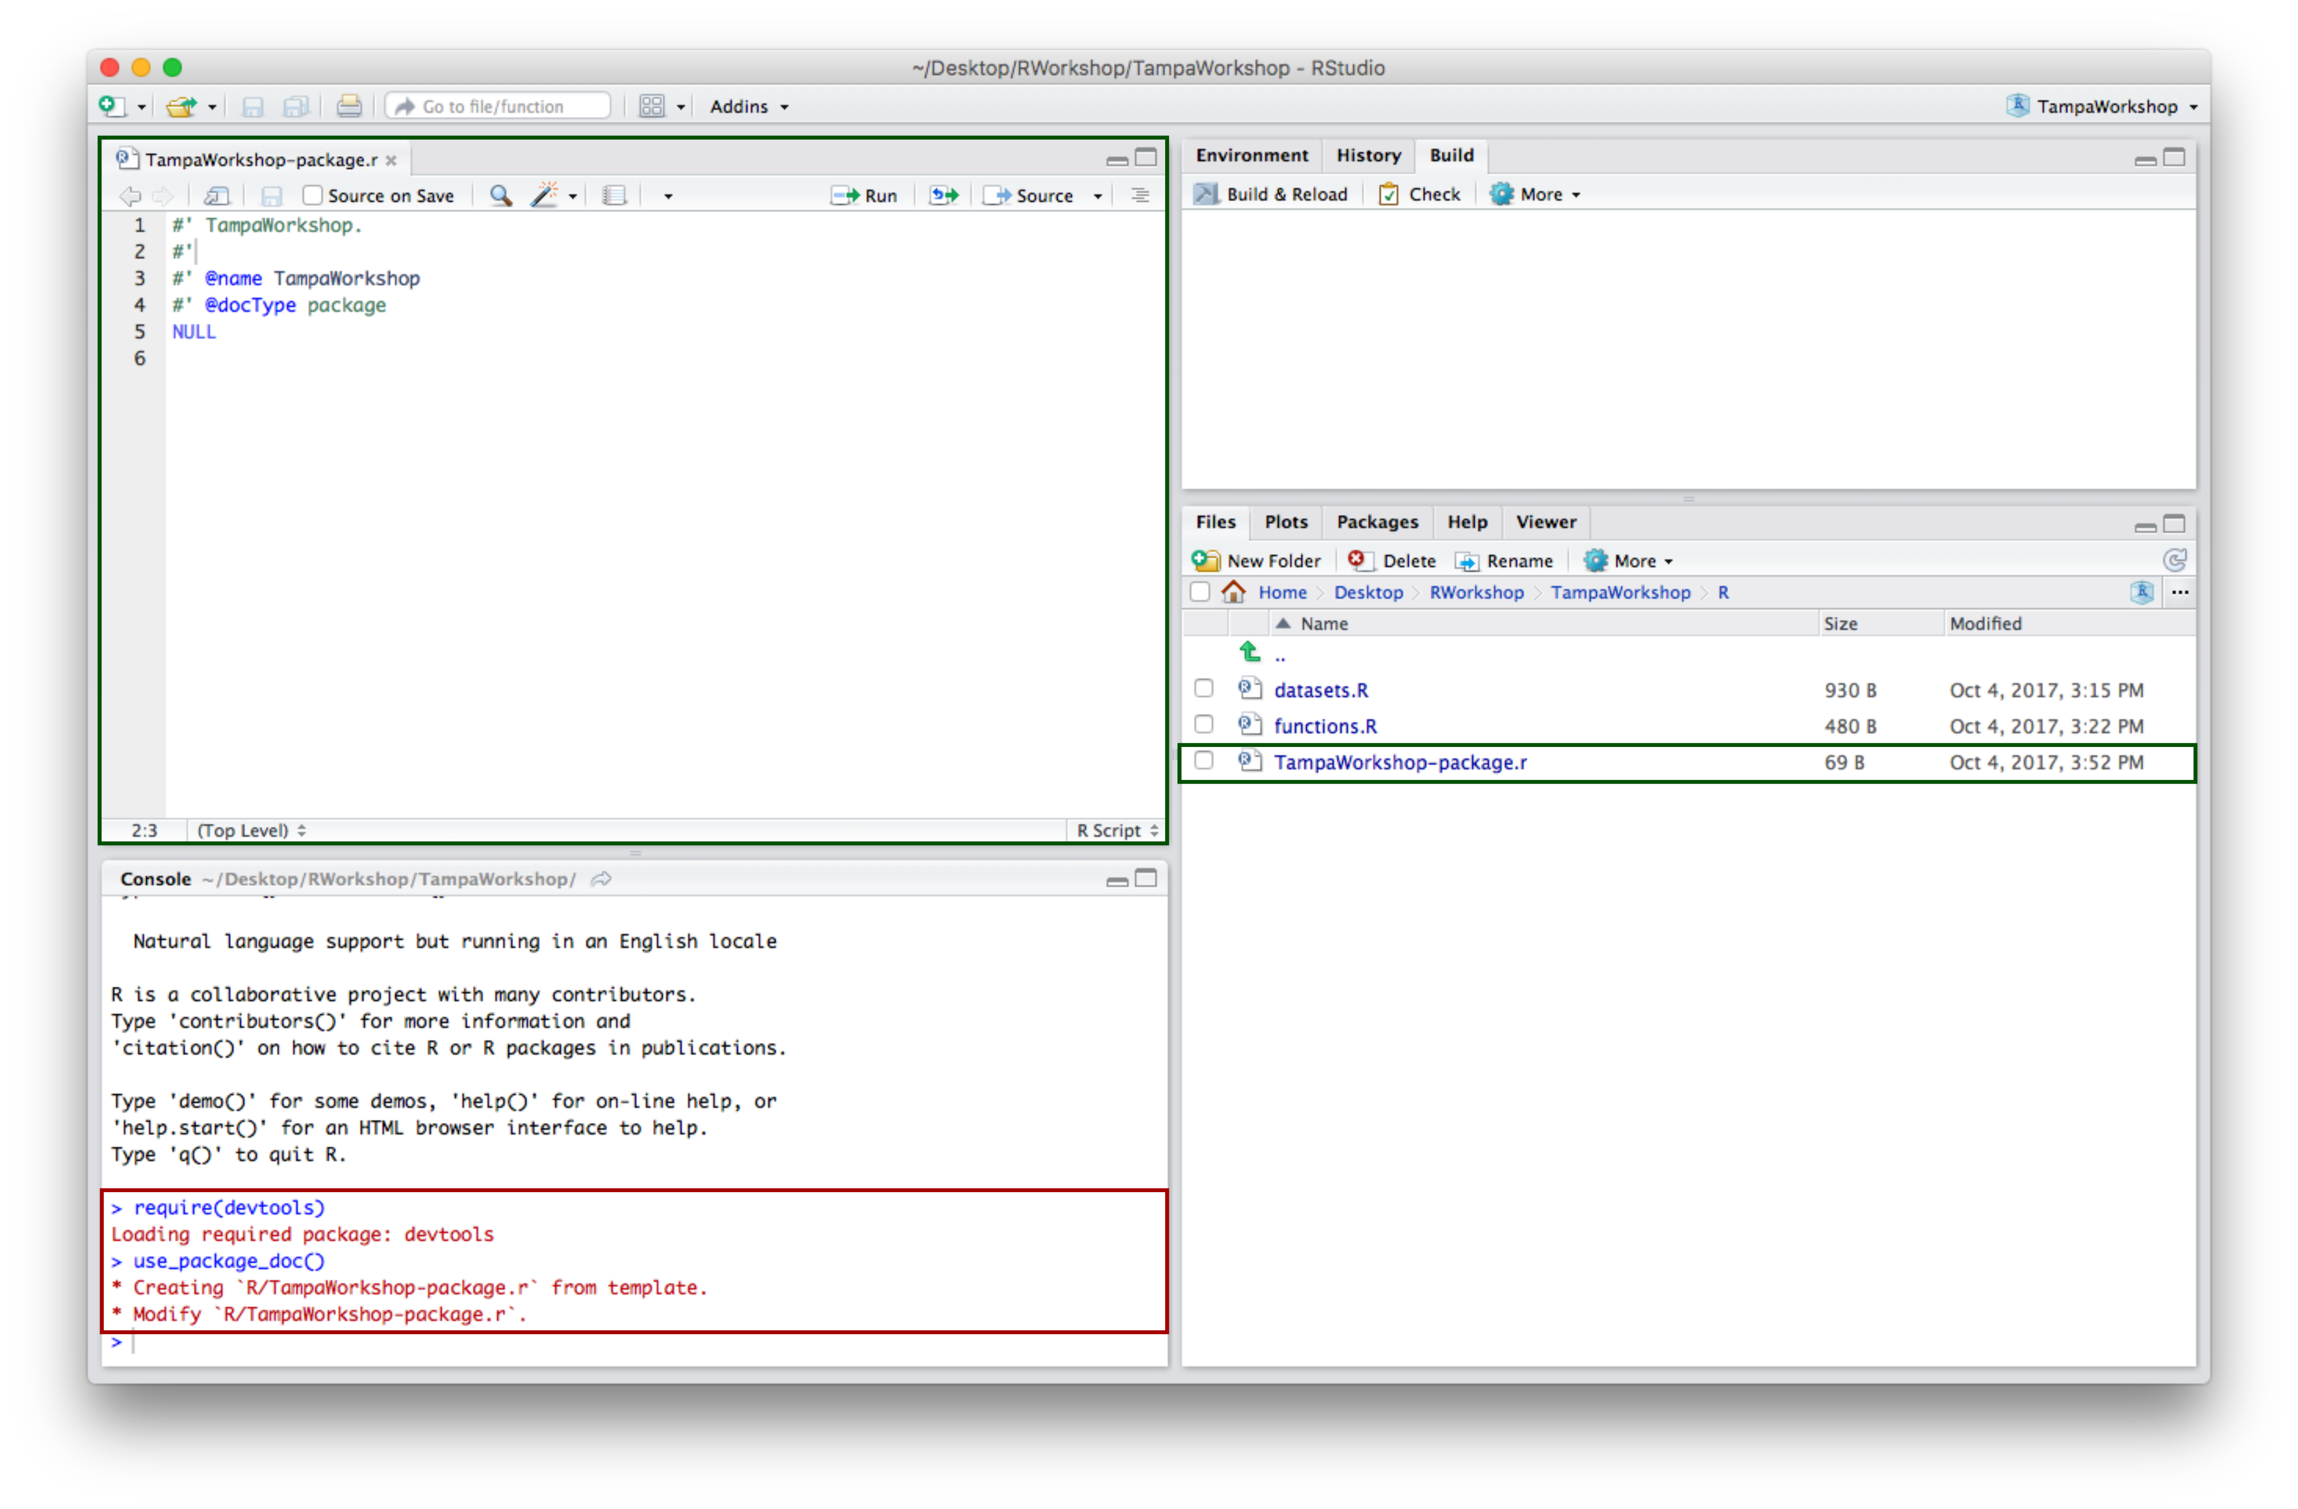

1. You can edit the created file to document the package as a whole. Click on Build \& Reload - or Install & Restart - to update your package in the Packages tab. Use ?PackageName (here ?TampaWorkshop) to see the package medata in the help screen.

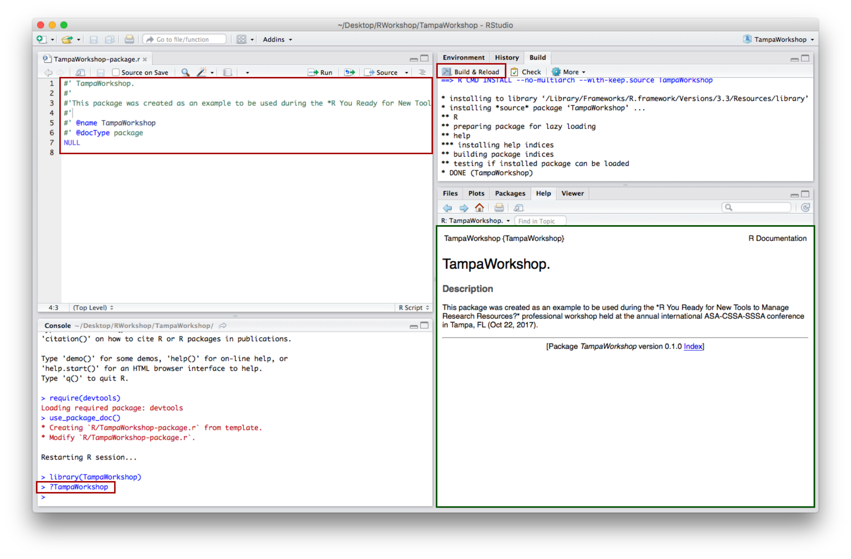

1. Once you have included and adequately documented all datasets and functions in your package, you can export your package as follow. In the Build tab, click on More and select Build Binary Package

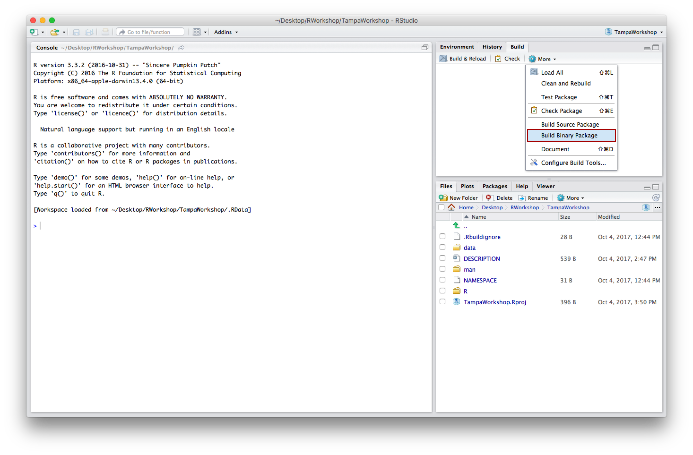

1. Your package has now been exported into a .zip package if you are using Windows - or into a .tgz file if you are using Mac - and can be found in the same directory than your original package folder.

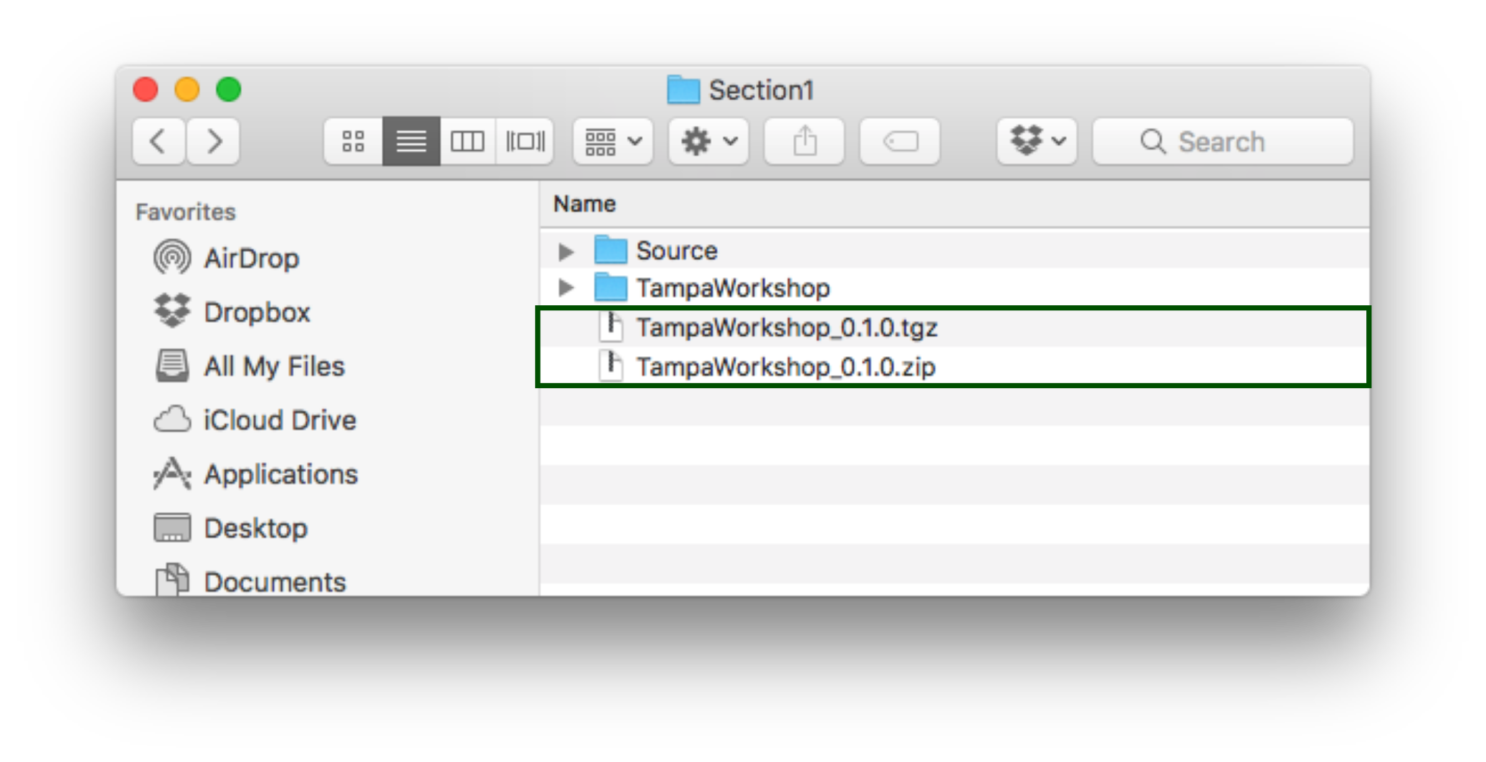

# Section 2. Producing a Manuscript with R Markdown

In this second section you will learn how to use R Markdown to integrate data visualization, data analysis, and manuscript/report writing into a single software application. You will be guided through a step by step tutorial that uses the R-package created in Section 1.

## 1. Create a New Markdown Document

1. Click on File >> New File >> R Markdown to open a new Markdown document.

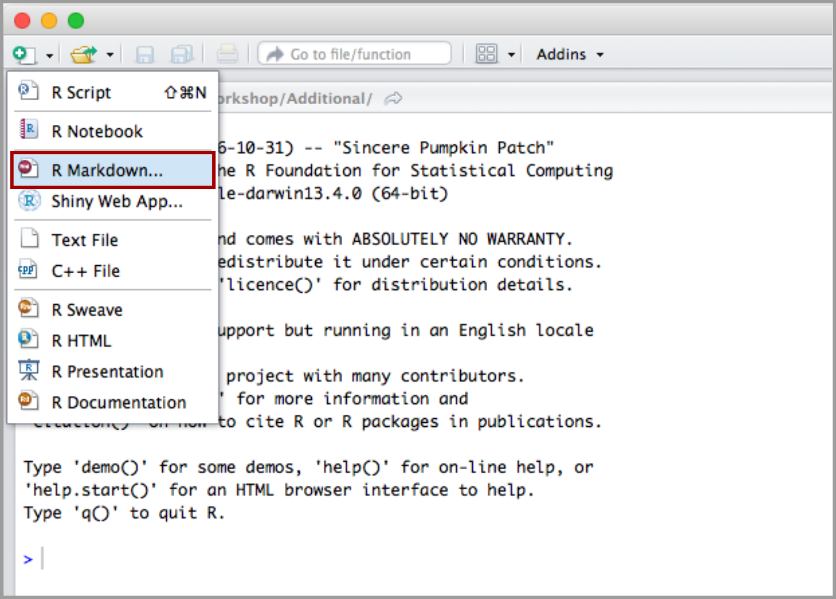

1. In the New R Markdown window select the type of document you want to create -here Document- , specify a title - optional, can be changed later -, the author(s), and an output format - for now select HTML. Click ok to continue.

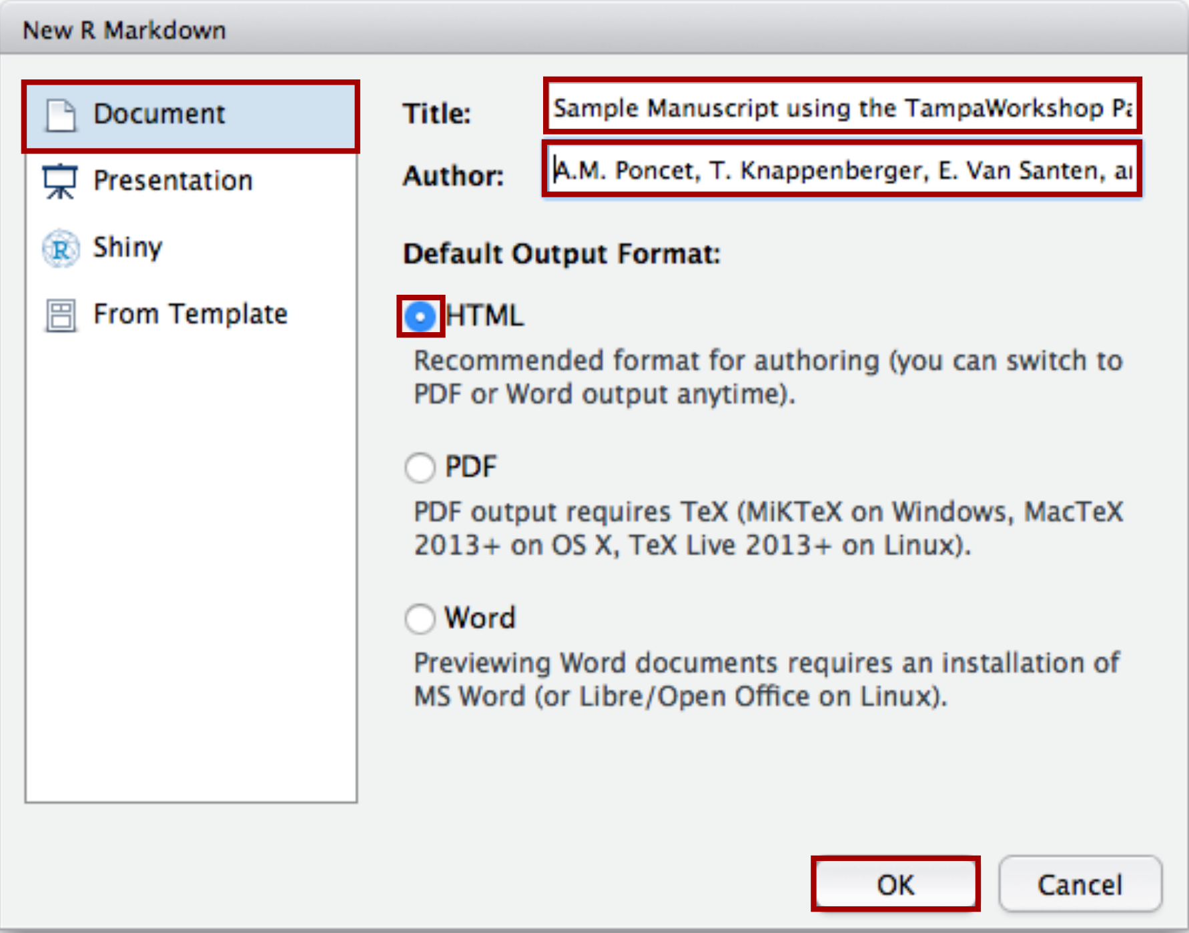

1. You obtain the following screen. The first four lines define the title of the document, authors, creation date, and output format. You can generate the HTML document by clicking on Knit button.

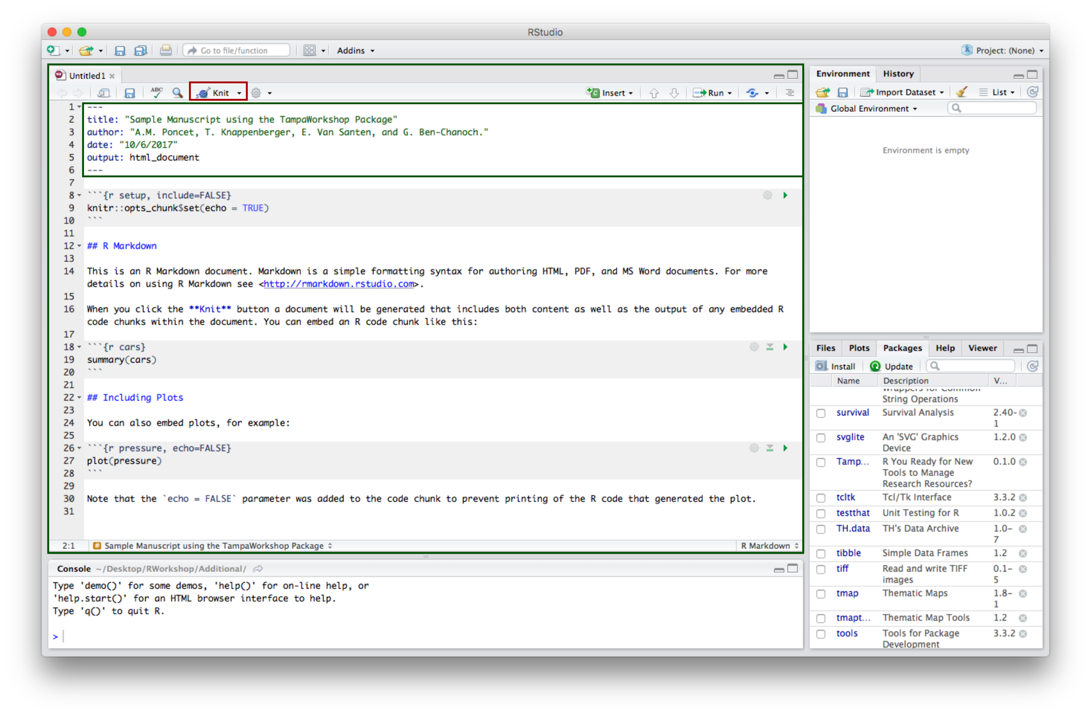

1. You obtain the following result.

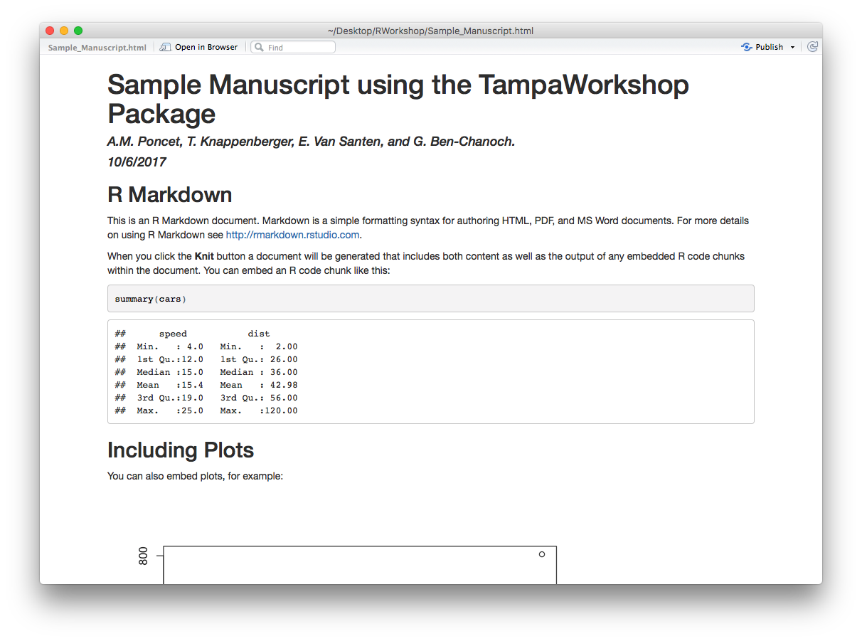

## 2. Write the Manuscript.

1. You can structure the document as presented in the figure below. Use # for first level headers and ## for second level headers.

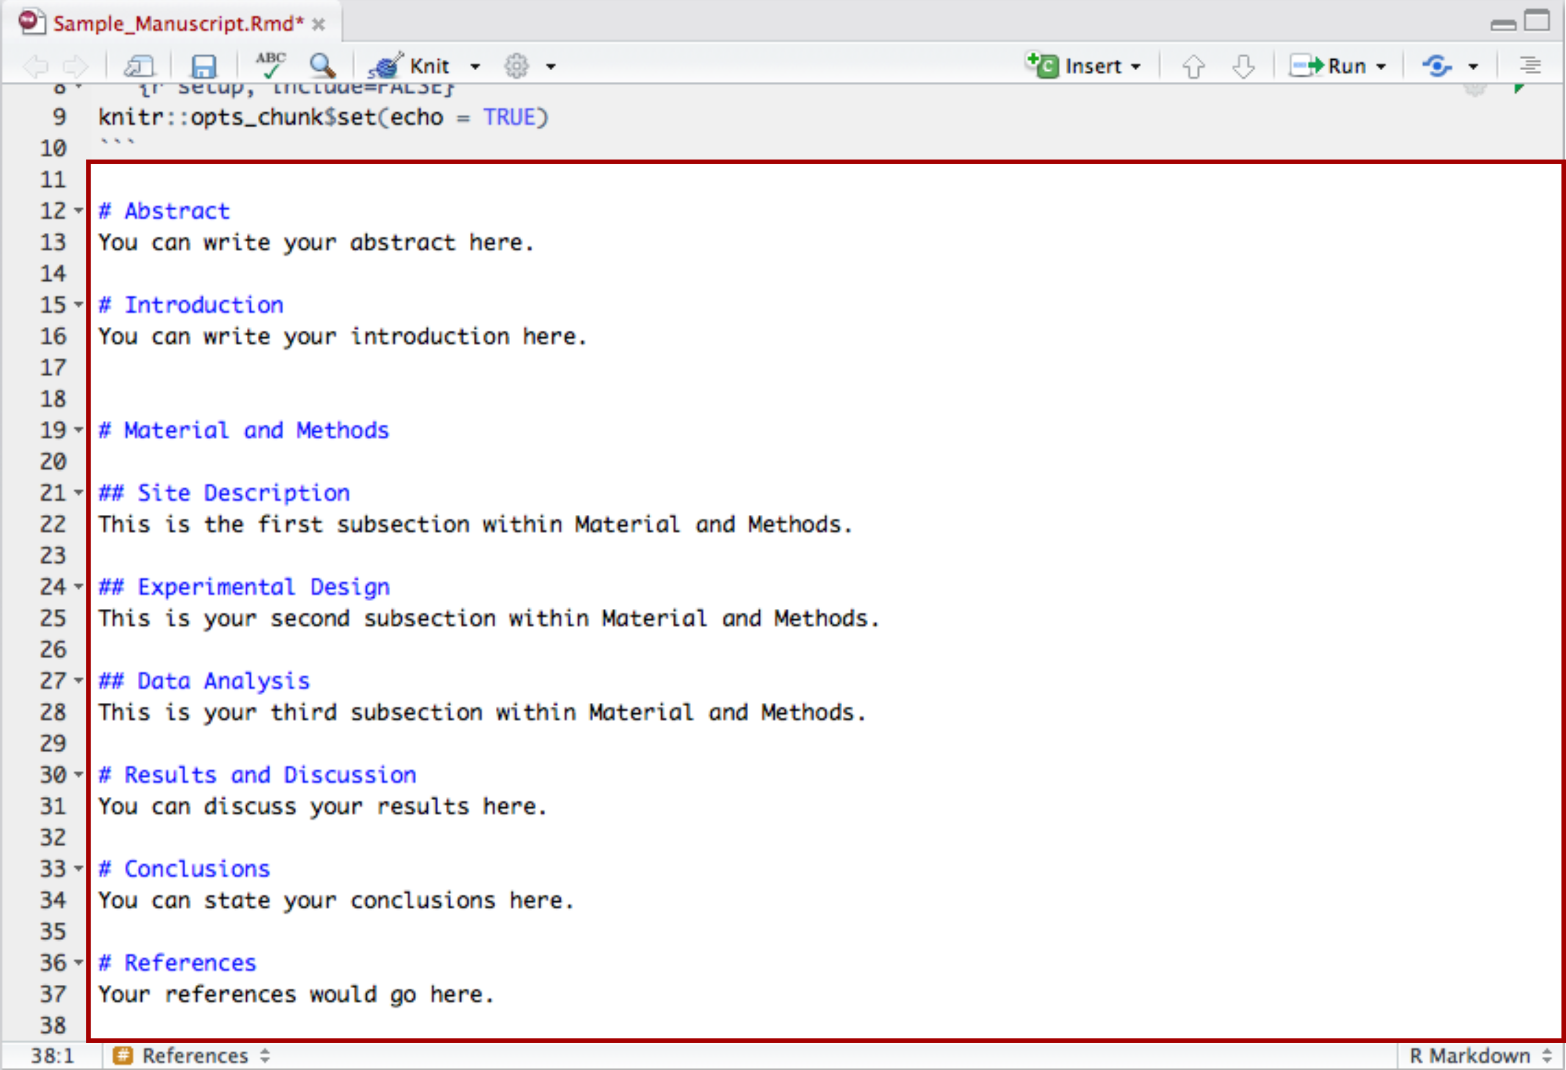

1. Leave a blank line to start a new paragraph. Use \* and \*\* to italicize and bold text, respectively. Use \ as an escape character.

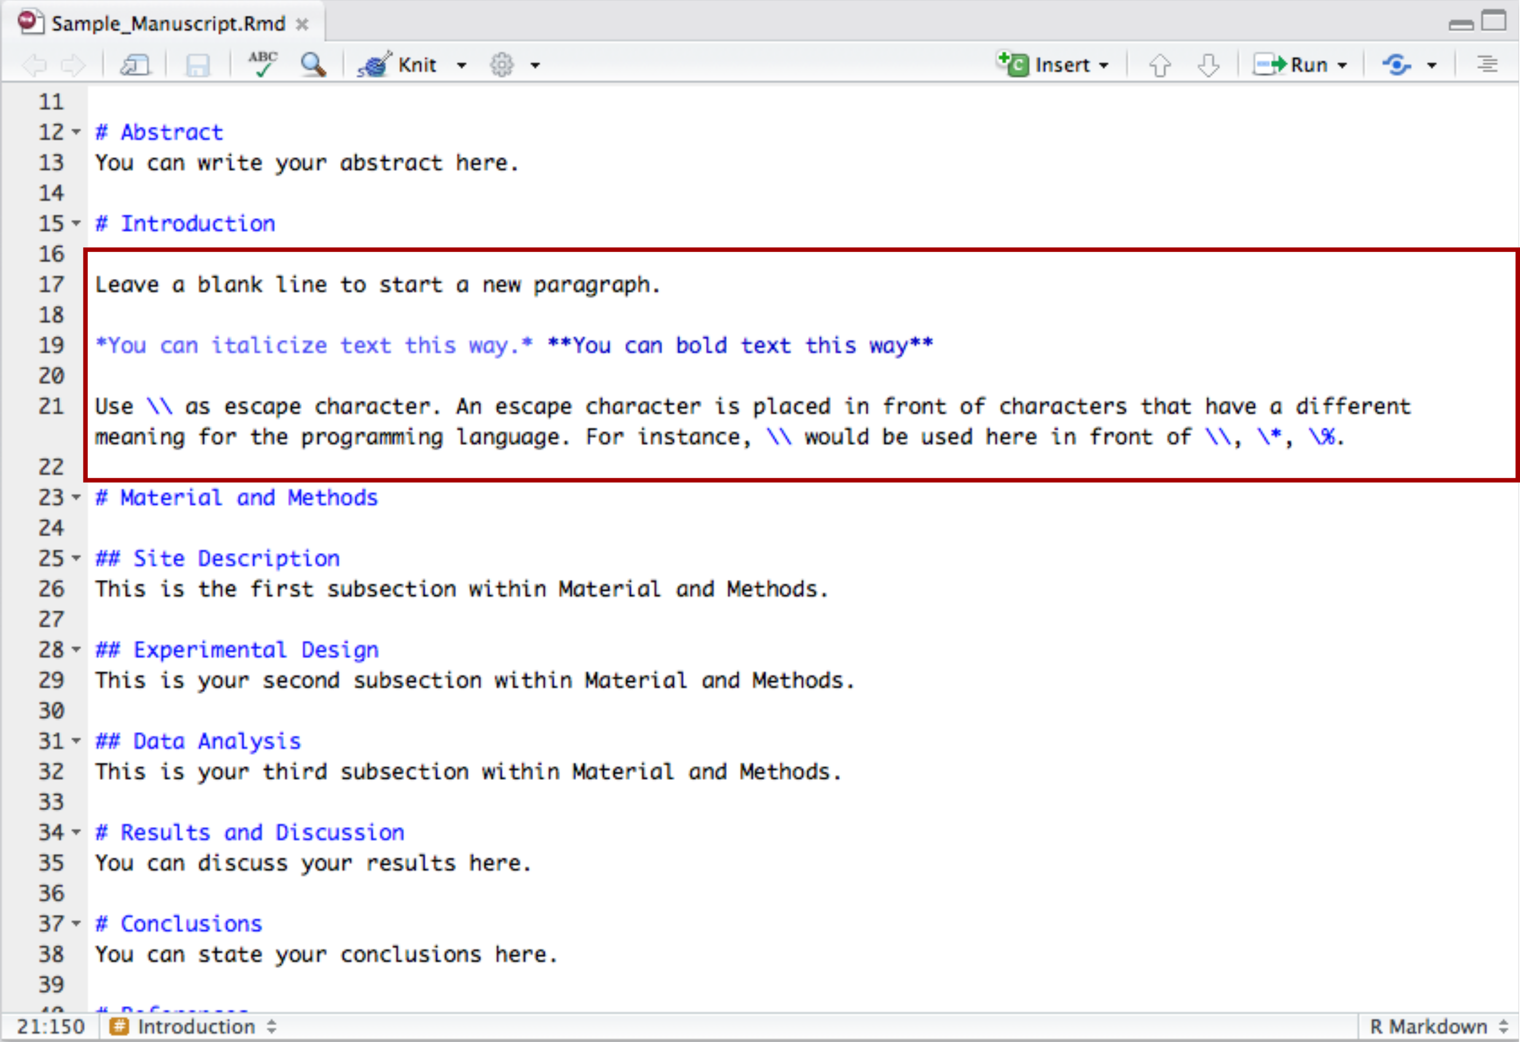

c. You can create non-ordered and order lists as presented in the figure below.

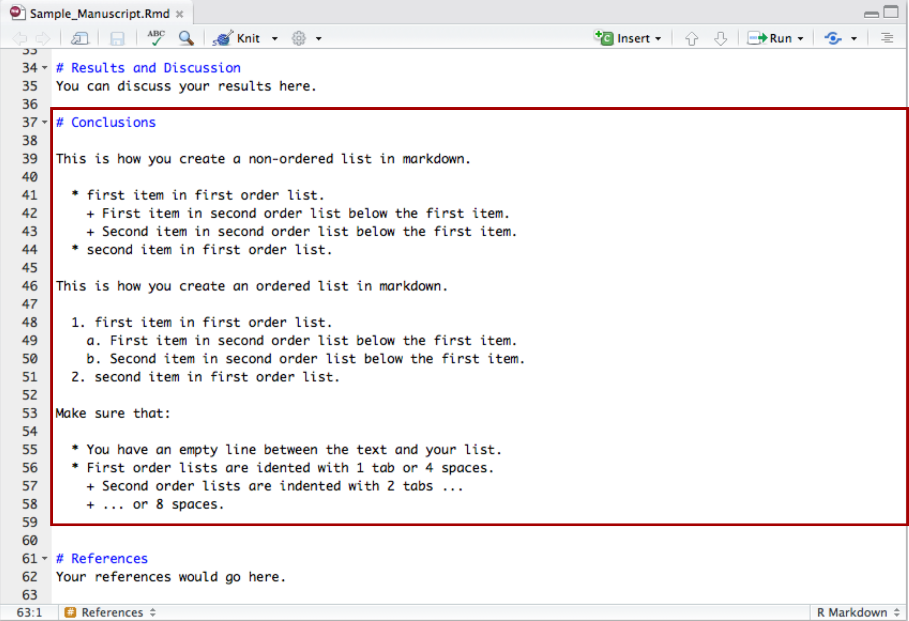

1. You can add figures using ![caption]{Figure Path and Name}

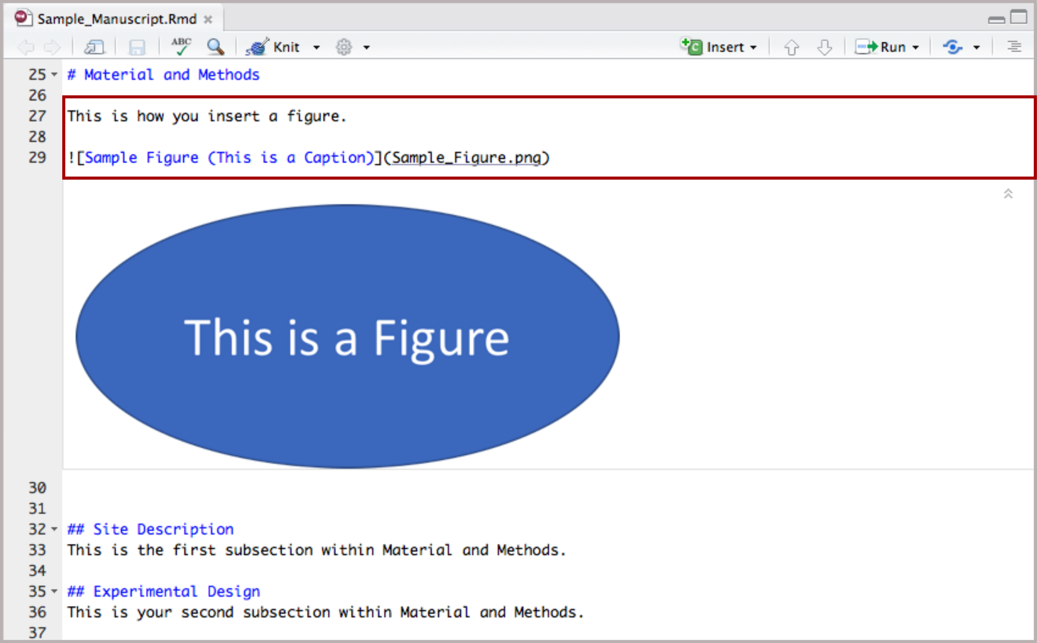

1. You can also add tables as presented in the figure below. Use \| to separate columns. Use - to separate header from rows below. Use :to determine text adjustment within individual columns. Use :--- to left-justify, :---: to center, and---:` to right-justify.

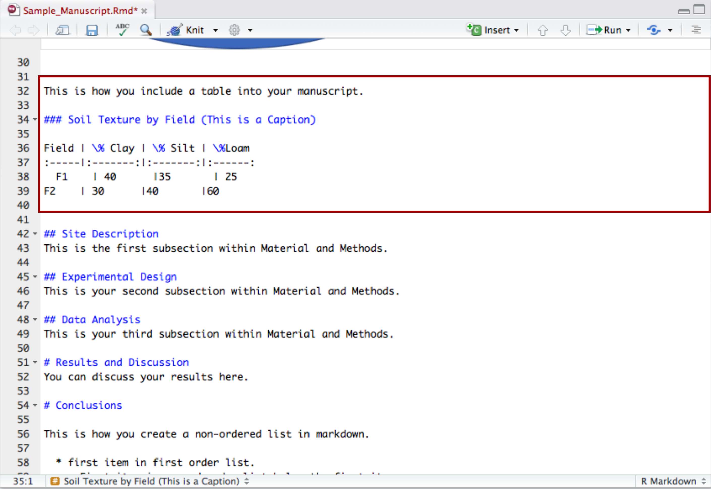

## 3. Include R Code and Outputs to the Manuscript.

1. To insert R chunks within Markdown, click on Insert and select R.

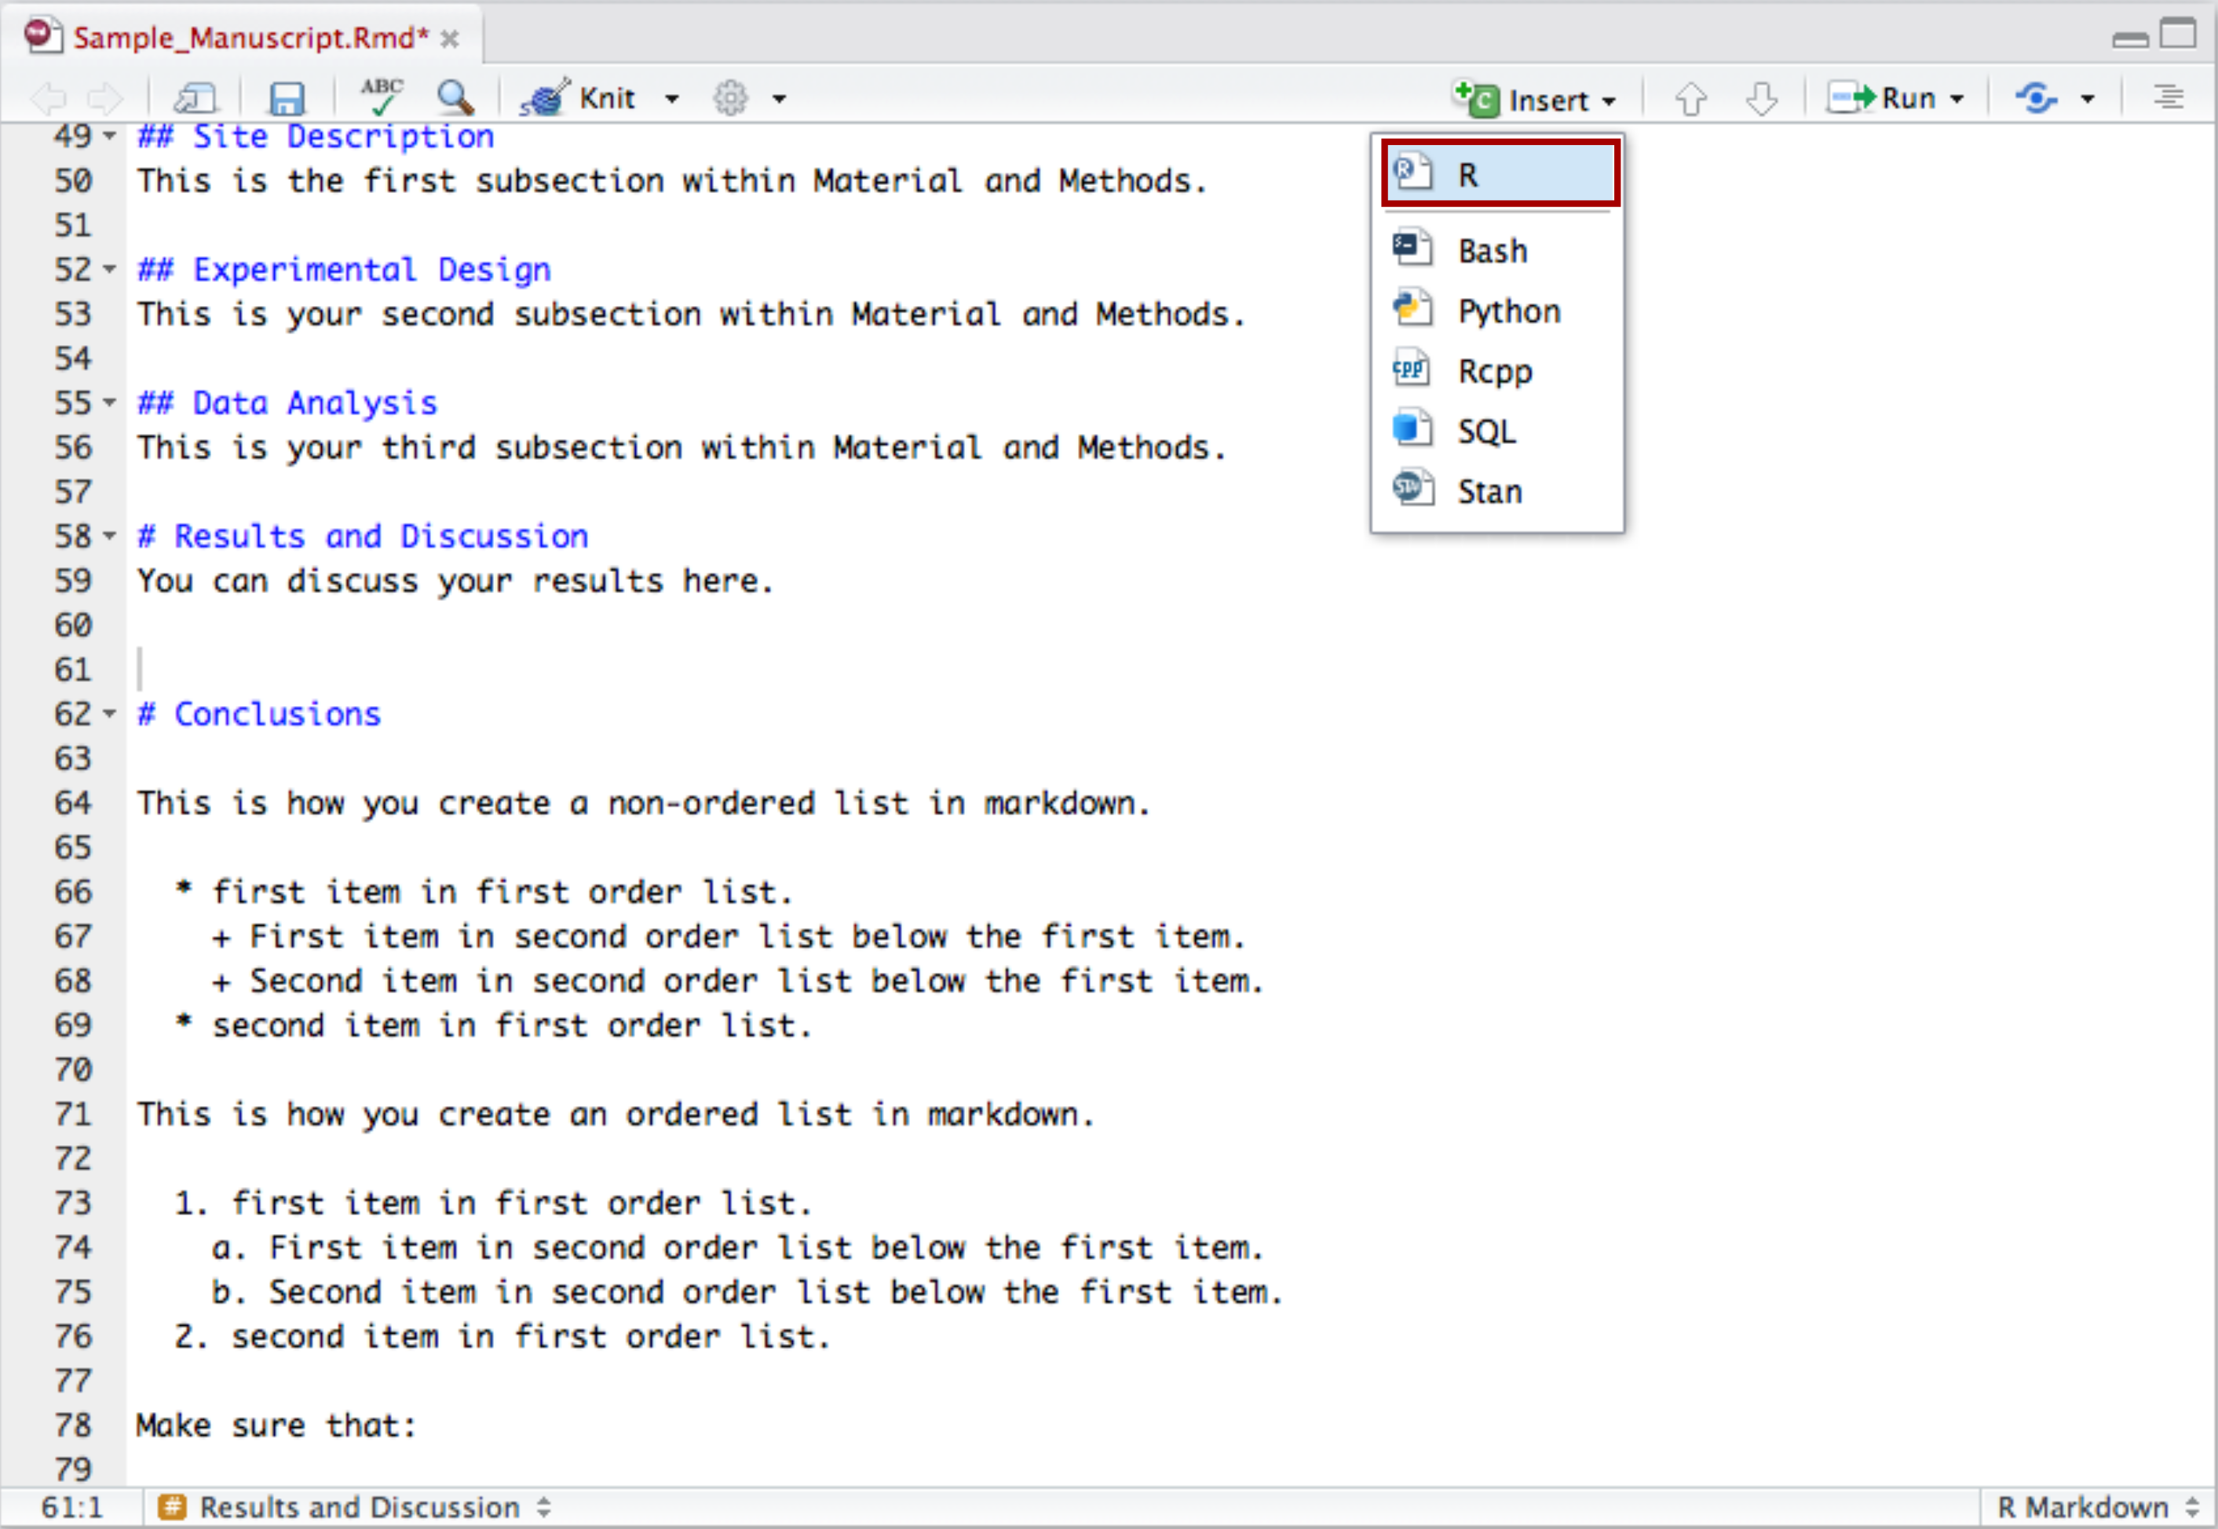

b. You can specify if the code should be displayed, evaluated, and the results displayed within the R document using the echo = T/F, include = T/F, and eval = T/F parameters.

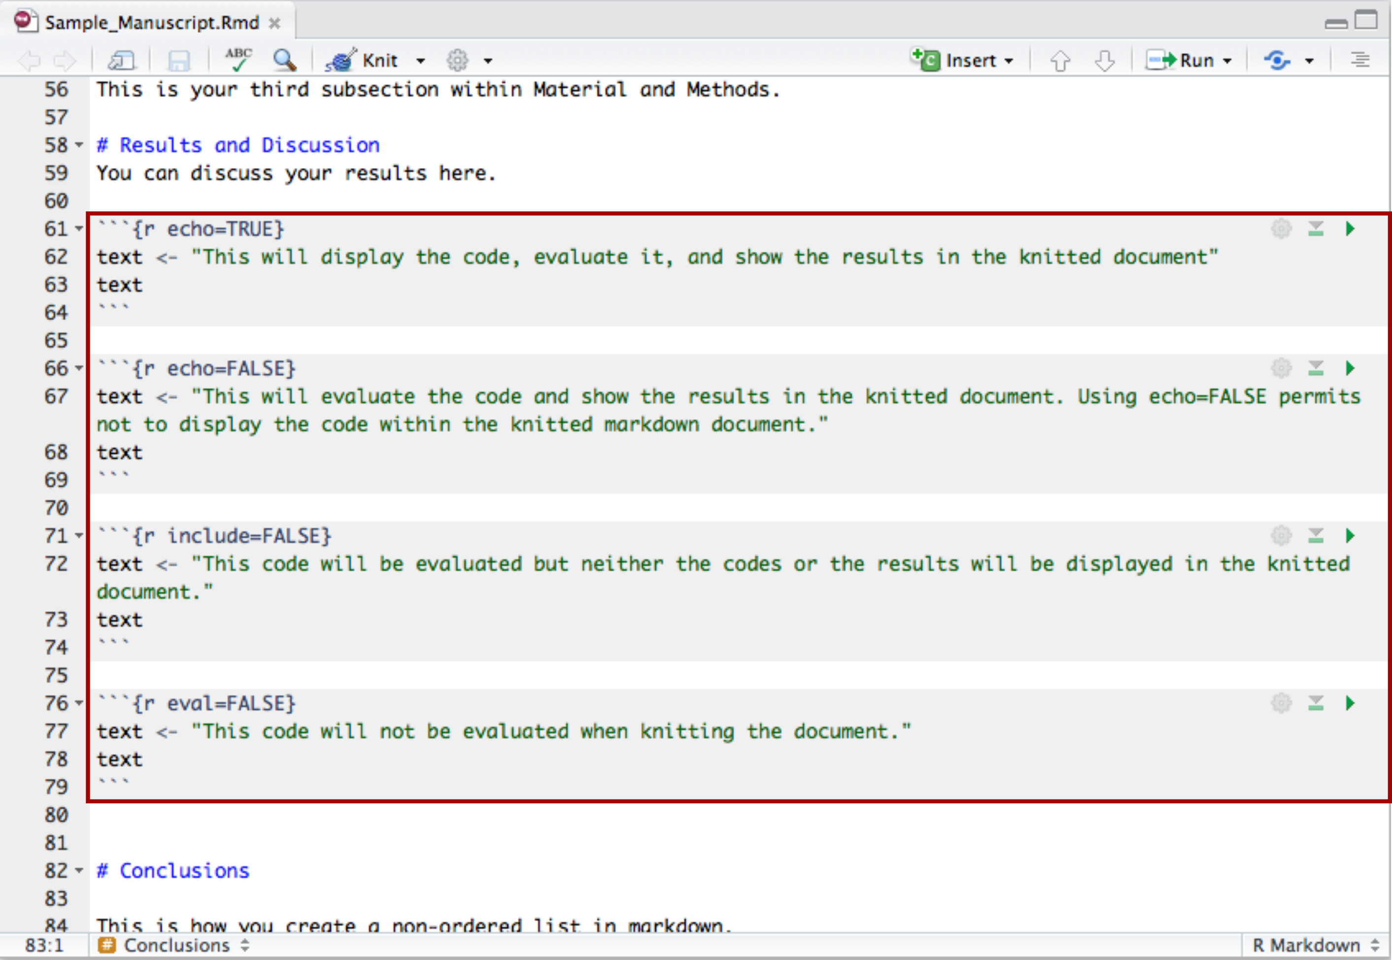

1. You can then type your code as you would in a R script.

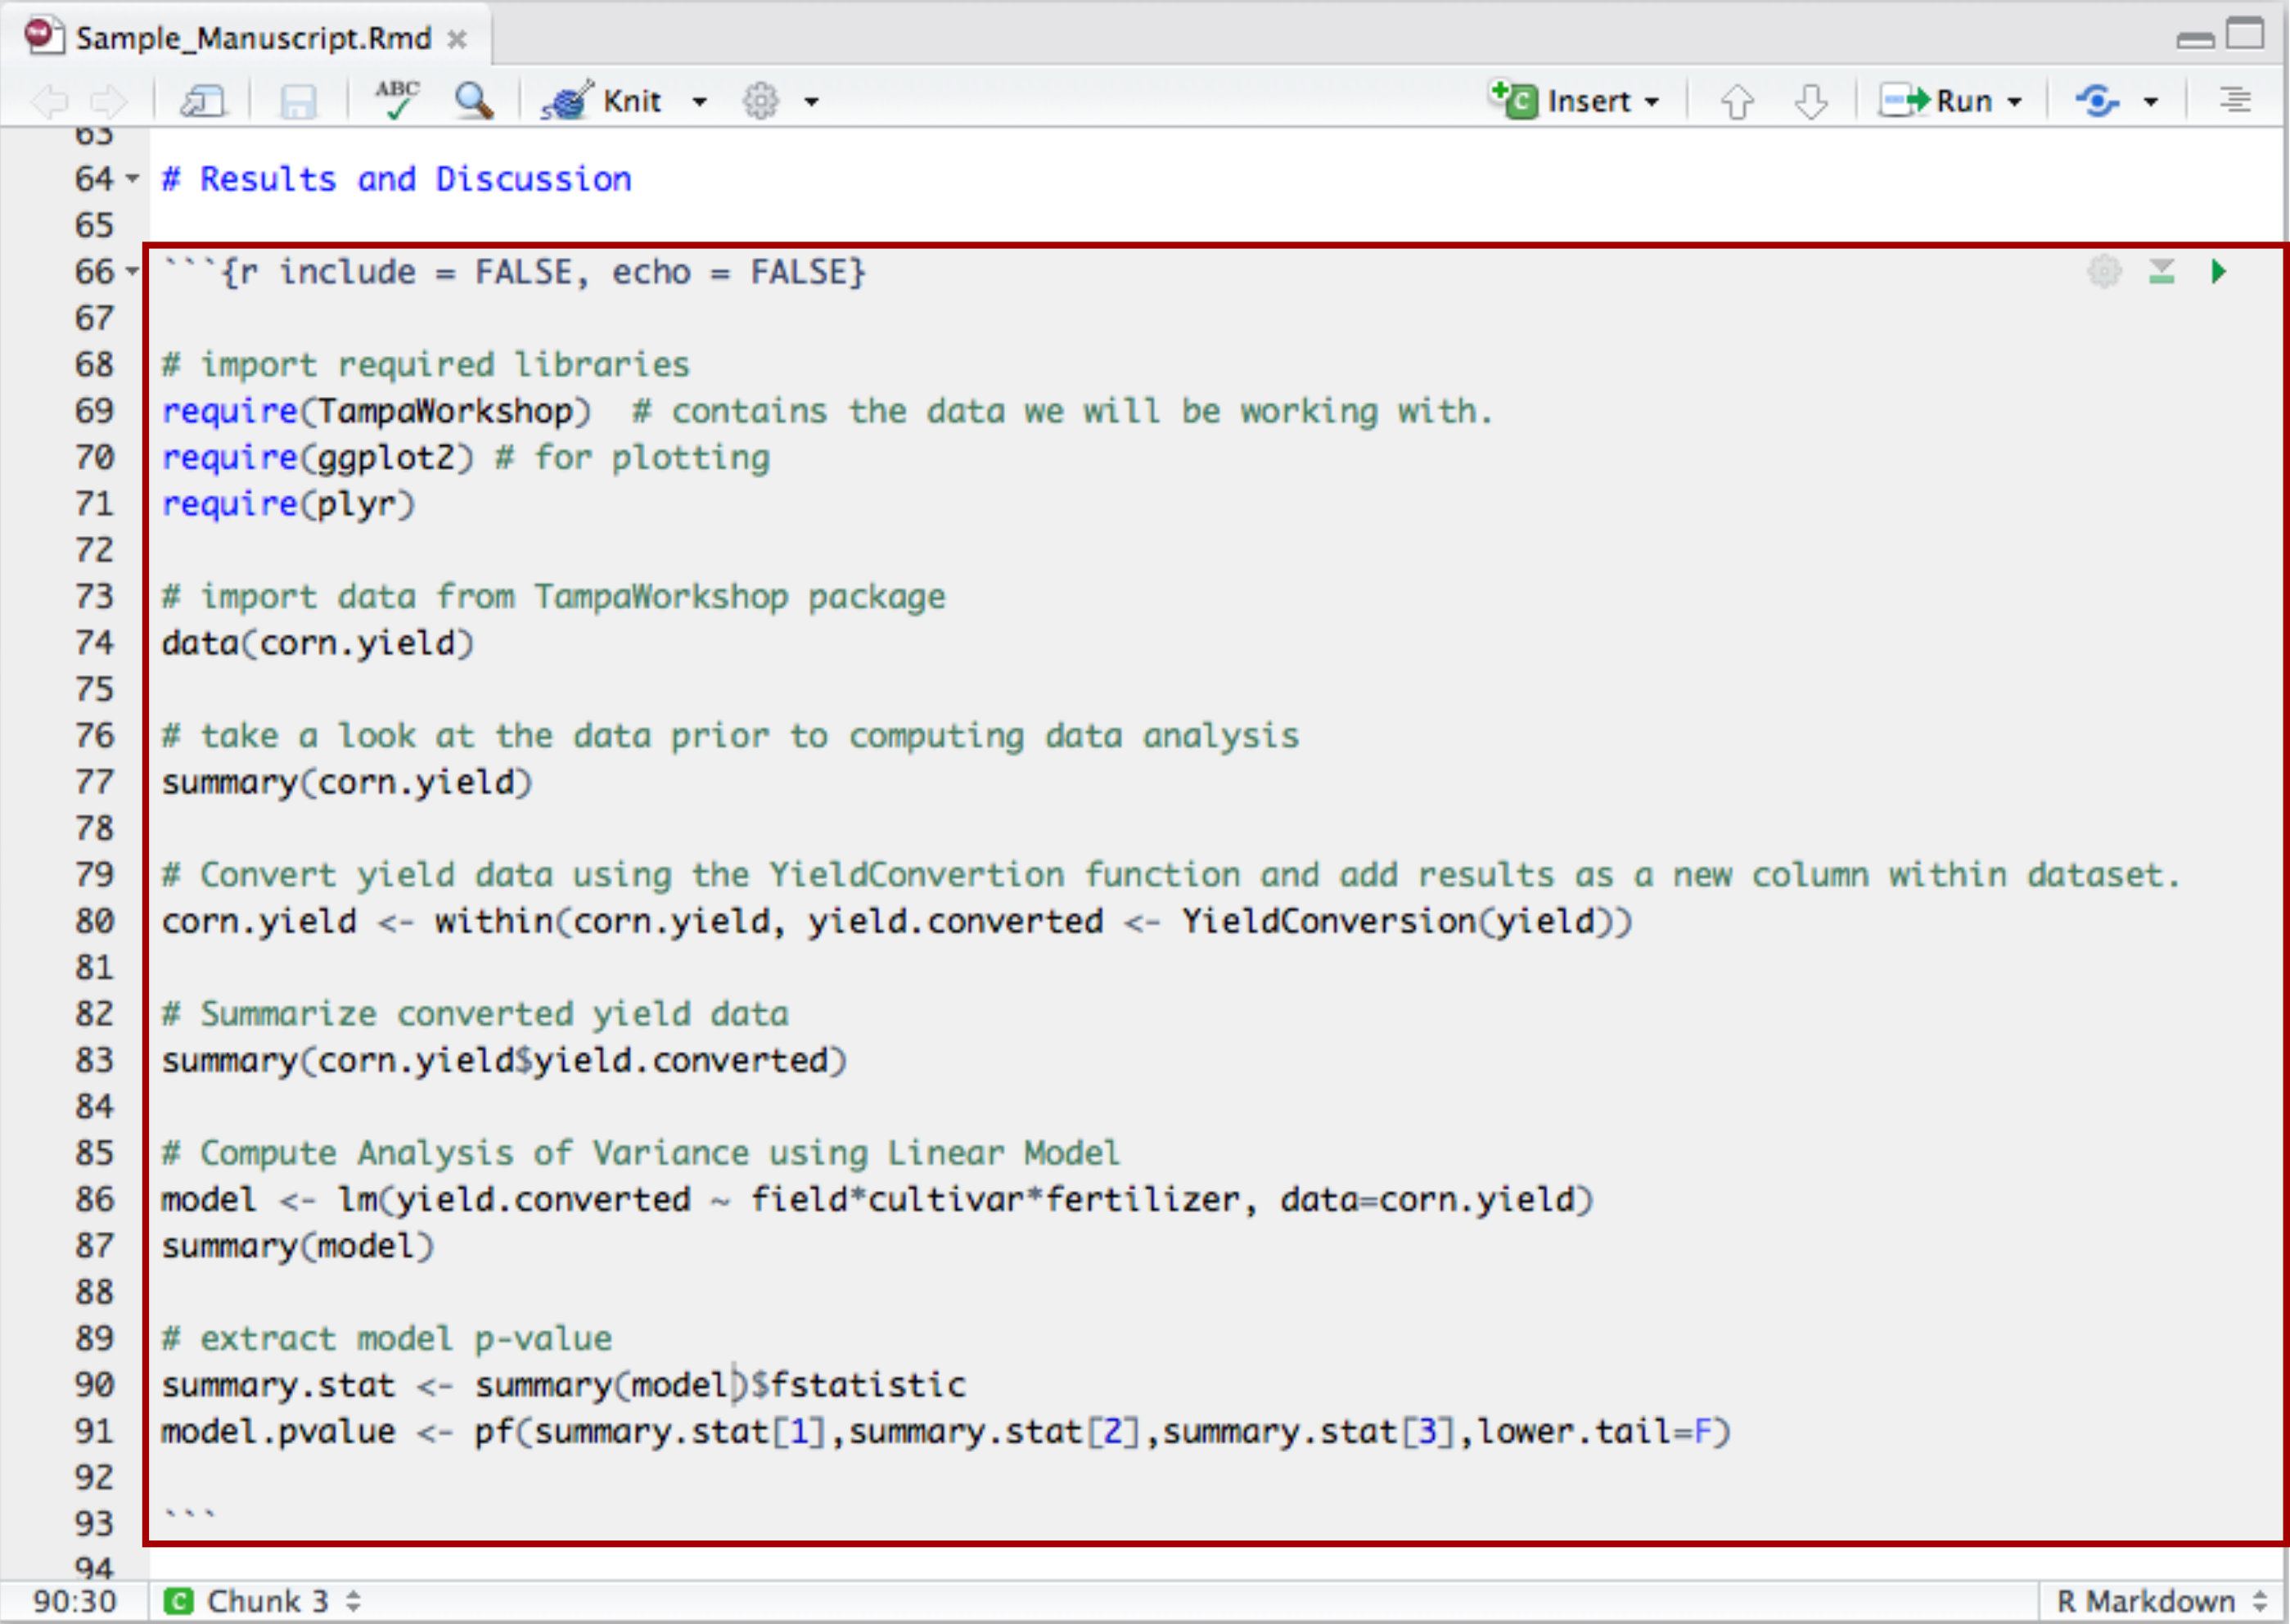

1. It is also possible to inline some R code using \(R code here)`` ...

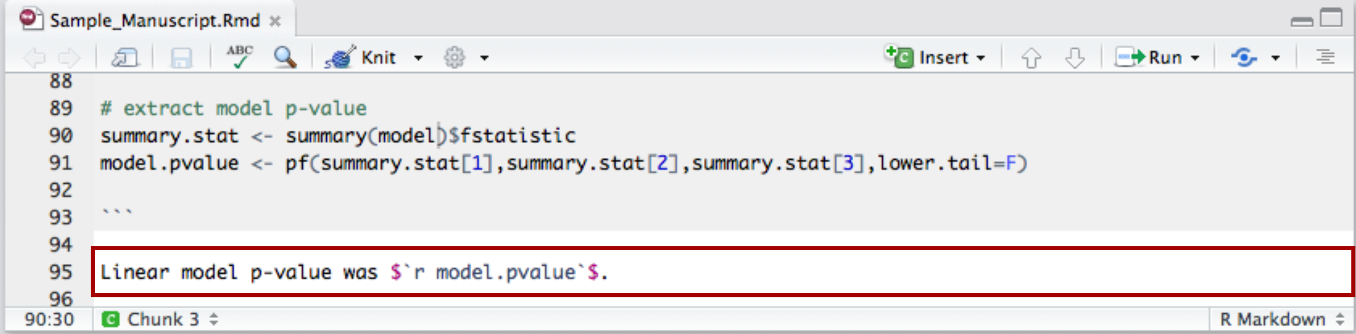

1. ... and insert graphics to the knitted document.

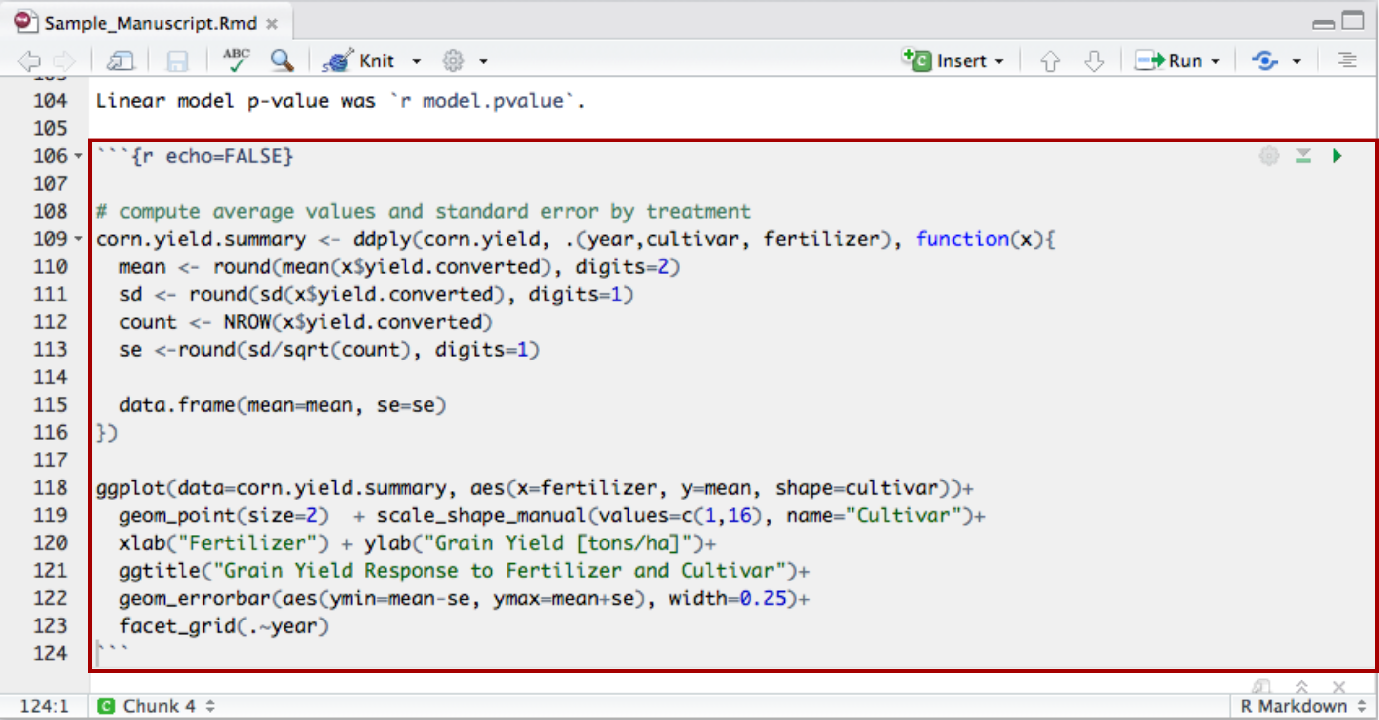

## 4. Insert References.

1. List your references within a bibtex or biblatex file (.bib)

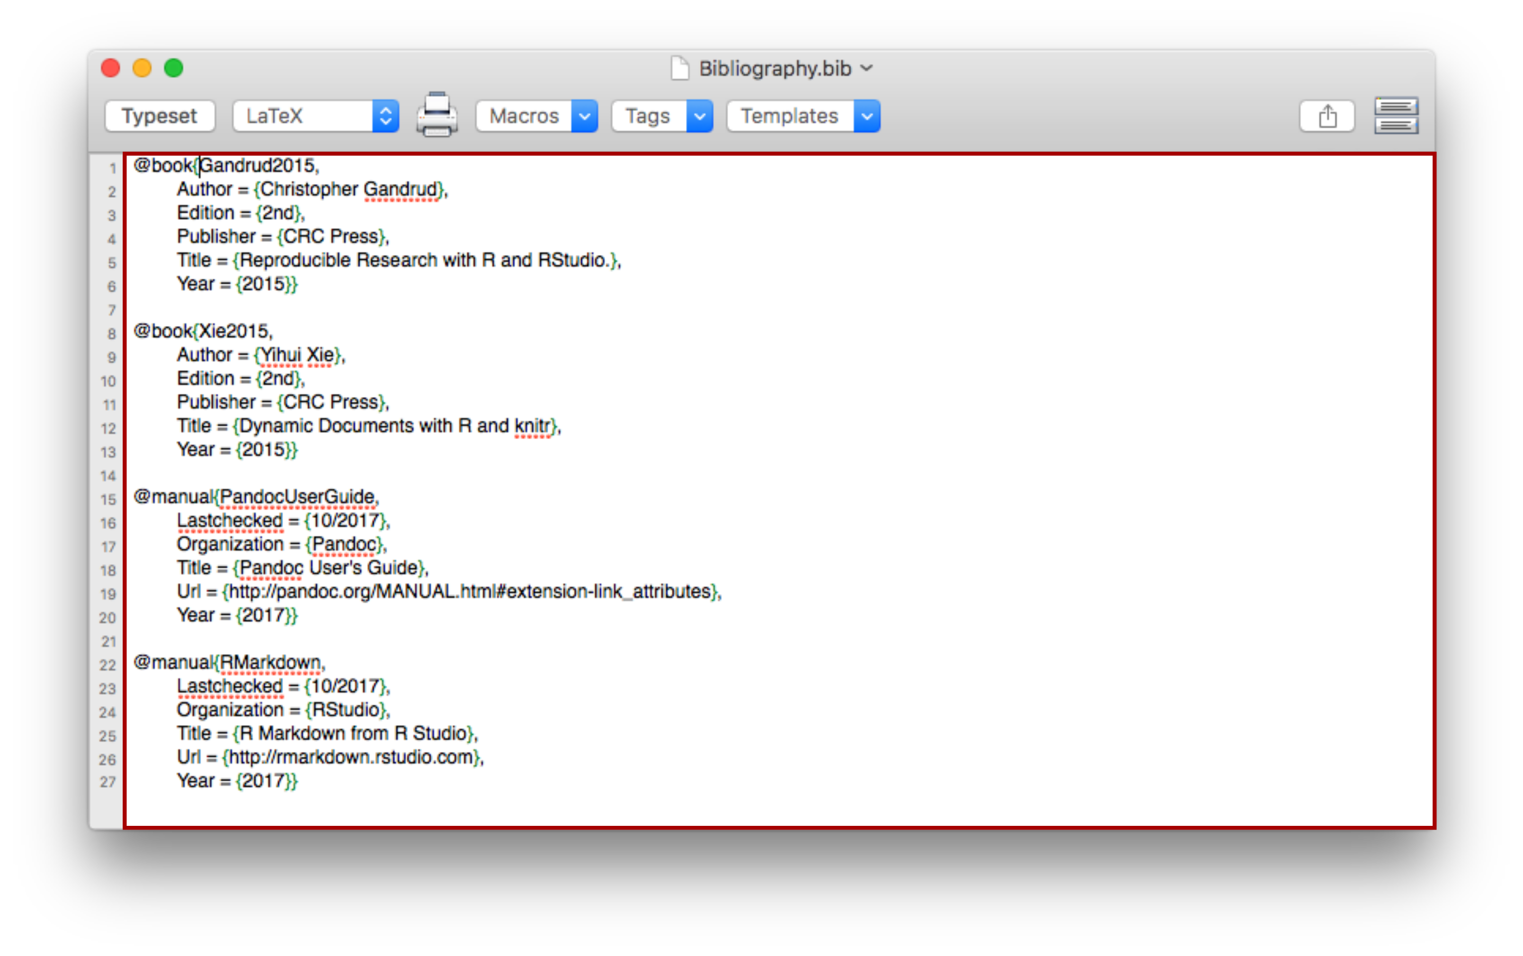

1. Save that file and specify the file name and path within the Markdown file header.

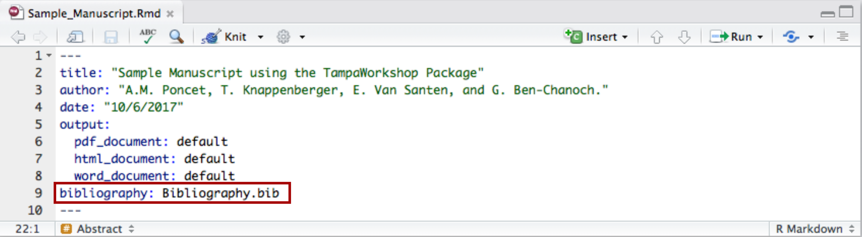

1. In-text citation go inside square brackets and are separated by a semicolumn. Each citation must have a key composed of \@ plus the citation identifier from the database. A minus sign before the \@ will suppress mention of the author in the citation. This is useful when the author is already mentioned in the text.

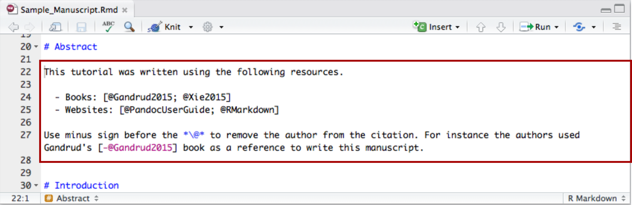

1. This provides the following result after knitting the document.

In text:

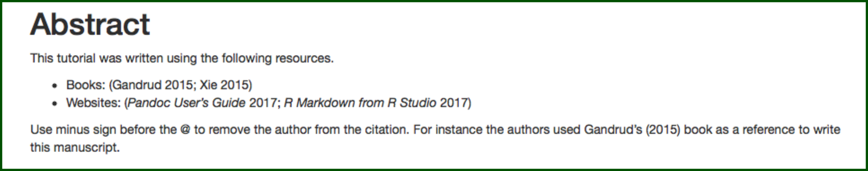

References Section:

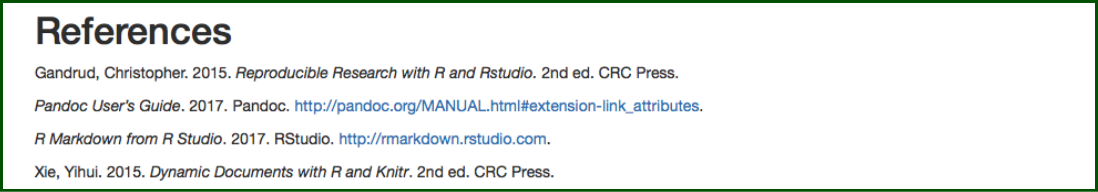

# Section 3. Exploring Different Markdown Outlets

Once completed, you can export your Markdown document into different formats including HTML, Word, and PDF (through Latex). To do so, click on the Knit button and select the desired outlet. In order to export your Markdown document to PDF you need to have already installed one of Latex distributions.

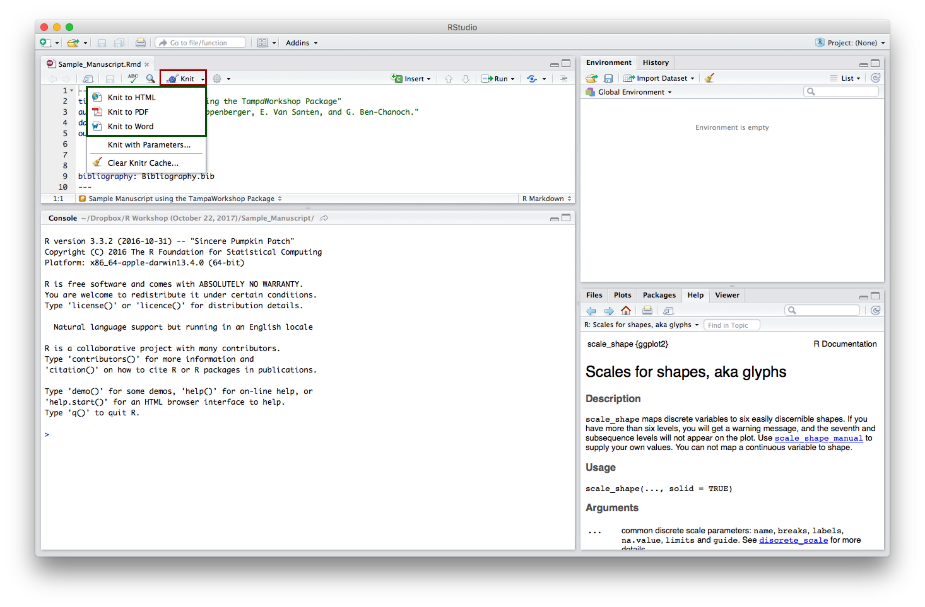

# Section 4. Update R-Package and Manuscript.

This fourth and last section will demonstrate the benefits of using R and R Markdown as an integrated tool for research. You will first be guided to update the dataset included within the R-package created in Section 1. You will then knit again the manuscript produced in Section 2 and compare the outputs.

## 1. Update the R-Package

1. Update the corn.yield dataset by adding the 2017 corn yield data.

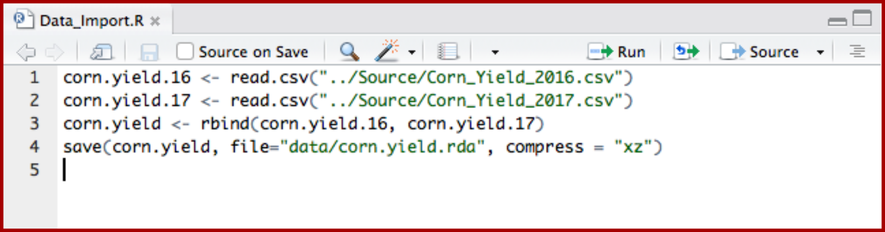

1. Open the TampaWorkshop package created in Section 1. Update the information provided in the dataset.R file and click on Build \& Reload - or Install & Restart.

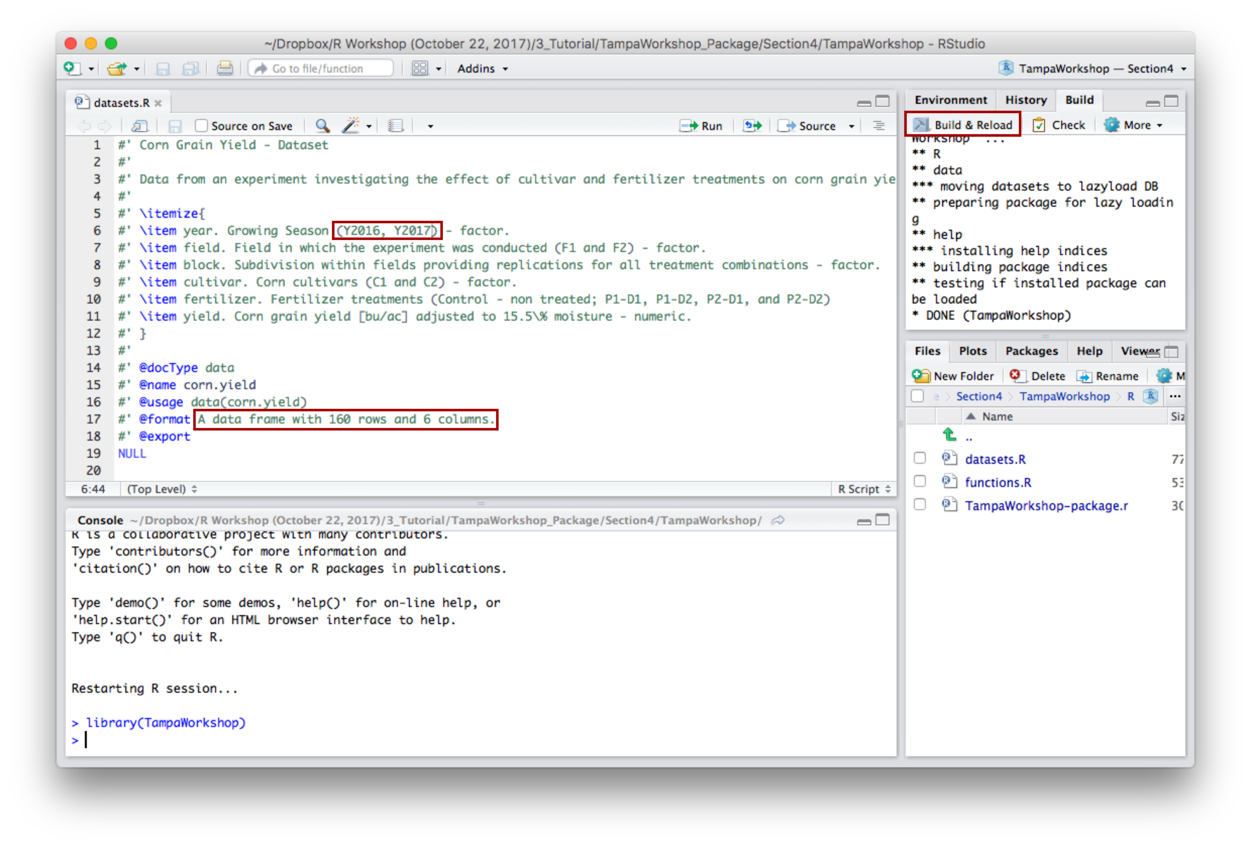

c. In the Build tab, click on More and select Build Binary Package

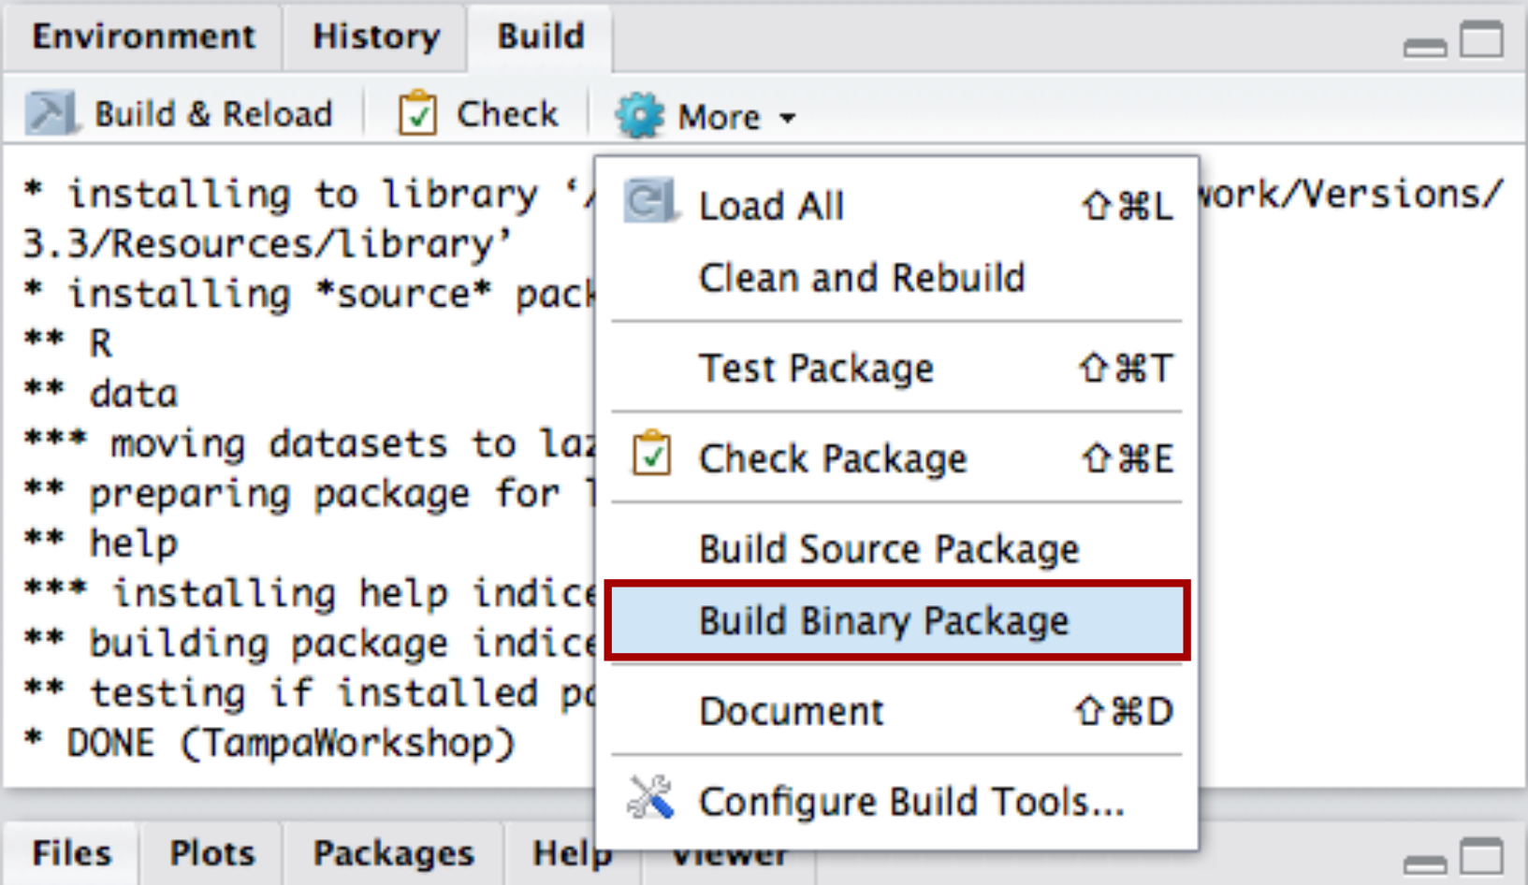

1. Make sure the corn.yield dataset has been correctly updated.

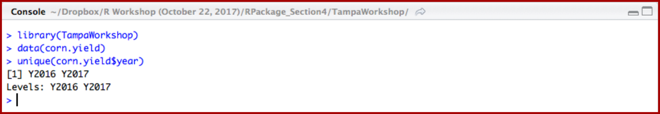

## 2. Update Manuscript

Knit the Markdown document created in section 2 and compare with previous version

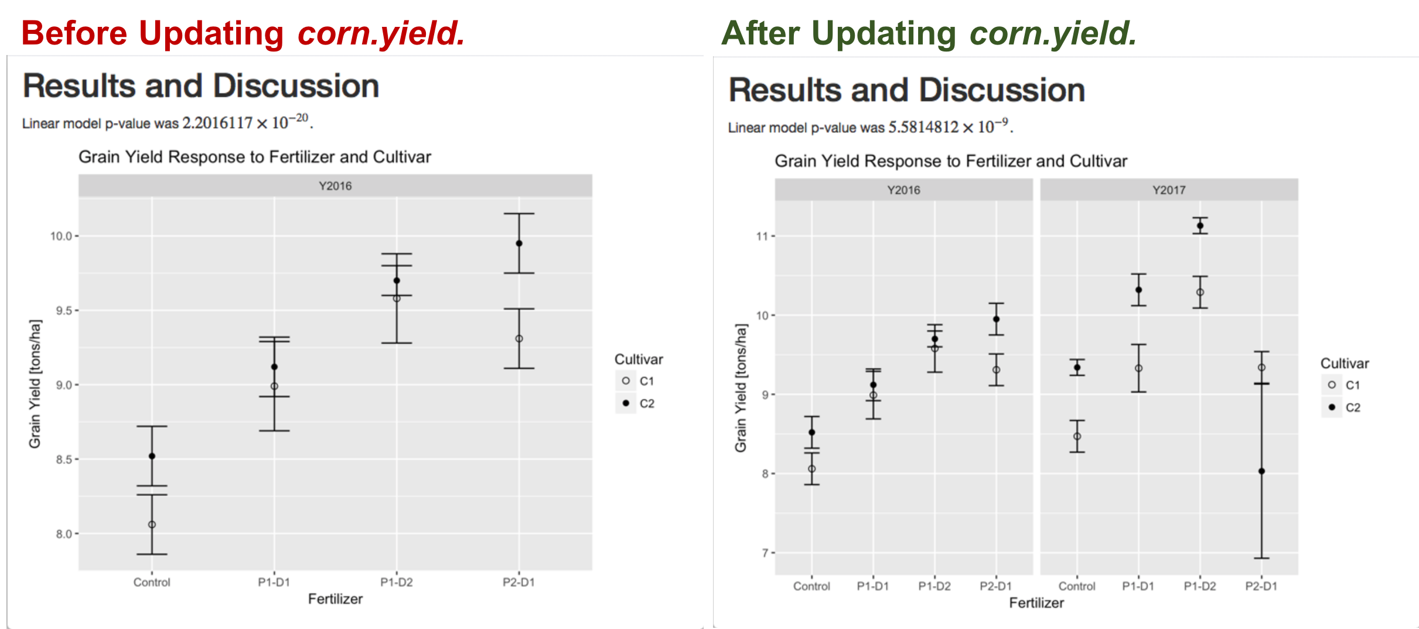

# References

Allaire, JJ, Joe Cheng, Yihui Xie, Jonathan McPherson, Winston Chang, Jeff Allen, Hadley Wickham, Aron Atkins, and Rob Hyndman. 2016. *Rmarkdown: Dynamic Documents for R*. <https://CRAN.R-project.org/package=rmarkdown>.

Gandrud, Christopher. 2015. *Reproducible Research with R and Rstudio.* 2nd ed. CRC Press.

RStudio, and Inc. 2016. *Htmltools: Tools for Html*. <https://CRAN.R-project.org/package=htmltools>.

Steve Dutky initial R port, S original by, extensions by Martin Maechler; revised, and modified by Steve Dutky. 2013. *Bitops: Bitwise Operations*. <https://CRAN.R-project.org/package=bitops>.

Tuszynski, Jarek. 2014. *CaTools: Tools: Moving Window Statistics, Gif, Base64, Roc Auc, Etc.* <https://CRAN.R-project.org/package=caTools>.

Urbanek, Simon. 2015. *Base64enc: Tools for Base64 Encoding*. <https://CRAN.R-project.org/package=base64enc>.

Wickham, Hadley. 2009. *Ggplot2: Elegant Graphics for Data Analysis*. Springer-Verlag New York. <http://ggplot2.org>.

———. 2011. “The Split-Apply-Combine Strategy for Data Analysis.” *Journal of Statistical Software* 40 (1): 1–29. <http://www.jstatsoft.org/v40/i01/>.

Wickham, Hadley, and Winston Chang. 2017. *Devtools: Tools to Make Developing R Packages Easier*. <https://CRAN.R-project.org/package=devtools>.

Wickham, Hadley, Peter Danenberg, and Manuel Eugster. 2017. *Roxygen2: In-Line Documentation for R*. <https://CRAN.R-project.org/package=roxygen2>.

Xie, Yihui. 2015. *Dynamic Documents with R and Knitr*. 2nd ed. CRC Press.